Student Number: 17667327

Course: BCAD2

Subject: OPSC7311

Lecturer: Nirasha Ramckurran

Assignment: Task 1

Due Date: 09/09/2019

OPSC7311 TASK 1

Contents

Research (Part A) 3

Introduction 3

Research of Existing Fitness Applications 4

Application 1: Accupedo Pedometer – By Corusen LLC. 4

Application 2: Samsung Health – By Samsung Electronics Co., Ltd. 16

Application 3: Pedometer Step Counter – By Leap Fitness Group 27

Comparison of Applications 38

List of Features to Implement: 41

Conclusion 42

Design (Part B) 43

Introduction 43

Overview 44

List of Functions 45

User Interface Design 47

Detailed Listing of Data and Types 58

Project Plan 60

Conclusion 64

Bibliography 65

# Research (Part A)

## Introduction

We have been tasked with researching three fitness applications, in order to gain insights into features which we must implement in our Android fitness application for our task two and three submissions. The application should focus on running fitness, which uses the accelerometer built in to a smartphone to measure the number of steps the user takes each day. The main goal of the application is to improve the fitness of the user, by allowing the user to set up fitness goals, such as reaching a certain step count per day, and weight targets. The three fitness applications will include this functionality at a minimum, but also include their own innovative features, which we could gain inspiration from.

The three fitness applications will be assessed based on design, functionality, accuracy, and reliability. During the research process, an application overview, strengths and weaknesses, innovative features, and screenshots of the three applications will be provided. An in-depth analysis of each application will take place, in order to gain valuable insights into how fitness applications should perform, and how they have been received by reviewers and users. A comparison of these applications will then be completed, in order to determine how they differ, and which unique features are available in each application.

After a thorough analysis has been completed, the best features which have been identified during the research phase of development will be assessed. This assessment of features will allow us to provide an informed decision on how we will implement our fitness trackers, such as which features we will include, and how we will design its user interface.

A specification document has been included in our summative assessment question paper, which includes functionality such as step counting, capturing images of meals and exercises which indicate their health, and setting user goals such as weight targets and daily step counts. In addition to these key features, the application will also allow users to specify unit conversion (imperial or metric), and secure user data by only allowing registered users access to the application. The application will allow users to store physiological information such as weight and height on their accounts, which is used to assess fitness and health. It will be able to calculate Body Mass Index (BMI) of the user, to provide a reference of their health.

In addition to the features mentioned, innovative functionality will also be included in our application submissions. The features which have been identified during this research phase of development will help to understand what functionality is frequently used by users, how we can improve upon this functionality, and which additional features may set us apart from the competition. In order to best understand the market for fitness applications, we must research existing offerings, which will be completed in the following section.

## Research of Existing Fitness Applications

### Application 1: Accupedo Pedometer – By Corusen LLC.

Overview of the application  
Accupedo provides a free to use pedometer application, which allows the user to specify a step count goal for each day and view progress represented on a progress chart. During the initial setup of the application, it will request physiological information, including user height, weight, age, and gender. It bases walking and running step distance on your physiological characteristics. This is then used to determine distance travelled each day, in order to provide the user with an accurate reading of their fitness. During the setup it requests the user to enter fitness goals, including step count per day, distance travelled, calories burned, speed, and active time it takes to complete the workout. (Corusen LLC, 2019)

The application also allows its users to set units to either metric or imperial during initial setup or later within the settings menu. The next step is to either sign up/ in to your account so that all your information is stored in the cloud, or you can use the application without signing in, and all information is stored locally. This provides an easy way for users to access the application, without having to pay for a subscription or even requiring internet access. The application is based on the pedometer (accelerometer) functionality in the Android smartphone, and only needs internet and GPS for additional functionality. (Corusen LLC, 2019)

When the application loads, the user is brought to the main screen of the application, which provides an easy to navigate user experience, and includes the following functionality:

Today screen with the current goal and step count represented with the use of a visually appealing circular chart. The chart displays current step count and progress based on the fitness goal specified during setup. In addition to this, a pause button has been provided so that the user can pause the recording of steps temporarily. Fitness metrics have also been included, such as distance travelled while walking, calories burnt, average walking speed, and time spent during walking or running. (Corusen LLC, 2019)

The user may also view their historical step count information on the home screen, for the current week. This is represented using a bar graph. The user can scroll down on the page, and view additional information, such as an encouraging quote for the day, and smart messages (further insights). Additional historical data can be viewed lower down on the page, which includes the type of exercise such as walking or running, location, distance travelled, calories burned, and steps recorded for the current day. Historical data is broken down into days, which allows the user to select the day and view further information. It includes a map of where the user has travelled, along with workout metrics such as active and total time of workout, and elevation is displayed on a graph representing elevation over workout time. (Brian Chau, 2015)

The historical data view also shows if the target goal has been reached for each day, indicating a percentage based on how close the user was to reaching their goal. This allows the user to track progress for each day and determine their overall fitness progress. (Brian Chau, 2015)

The main page also provides the ability to start a new walking, running, or biking activity. It shows the current location of the user on a map, and the route that they travelled along when exercising. Information such as time duration, distance, calories burned, steps taken, speed, and elevation are also included. (Brian Chau, 2015)

The user may add a workout session for a certain time, which will be included in the historical data. They can also edit historical data with information from other sources – for example the user can edit a running session step count with the step count provided by a Fitbit or Android watch, which may be more accurate. (Brian Chau, 2015)

Heart rate BPM can also be included, which will be stored in the historical fitness report. This does not use the camera to detect the heart rate, but simply lets the user enter a heart rate beats per minute figure, which has been recorded in some other manner Notes can be added in a similar way, where the note is included in the historical information on the date that it was added. (Brian Chau, 2015)

Additional functionality includes the ability to share daily logs with people, via any share method including email, messages, Facebook, and more. You can also email a CSV file containing all data collected by the application. A backup and restore feature allows for backups to be automatically created on Google Drive or on the device, further securing your data. (Bumgardner, 2019)

The menu contains functionality including the following:

* Purchase a premium subscription: This removes ads, automates the detection of walking sessions, and provides a satellite view on the GPS map. It is important to note that this pedometer application does not automatically detect workout sessions without this subscription. The paid version provides a much more easy way to track fitness as you do not have to open the application in order to track activities. Steps are however automatically recorded without the application being open.
* Chart that displays historical data: This provides the user with historical step count data on a graph.
* History: This provides the user with historical data and supplies a percentage of how close they are to reaching their daily fitness goal, which includes distance, step count, calories, walking speed, and time duration. This historical data is ordered by date, which provides an easy way to navigate the data.
* Share button: Provides the ability to share progress with other users.
* Settings: Allows the user to complete the following actions:
  + Sensing method: You can use the built in step counter, or Google Fit sensor (smartwatch or other such device).
  + Design and Display: Allows users to change theme colours, language, calendar settings, and animation settings. (Brian Chau, 2015)
  + Units: You can change the units from Metric to Imperial using this setting.
  + Personal: You can change your personal details here, such as birthday, gender, height, and weight.
  + Goals: Allows the user to set up a fitness goal, including daily step count, distance, calories burnt, speed, and daily workout duration.
  + Notifications: The application can email you when your daily goal has been reached. Additionally, the step counter can be shown as a notification in Android notification centre.
  + Version: Application details.
* Edit steps: You can manually change the step count for the day using this function.
* Backup: Allows the user to back up their fitness records to the phone or Google Drive.
* Delete history: Erases all fitness logs.
* Ability to sync data with 3rd party applications such as Caloriecoin and MyFitnessPal.
* Email CSV File: Allows the fitness logs to be sent via email.
* Help: Provides assistance via email, FAQs, and a user guide.
* Privacy Policy: Provides the user with privacy policy information.
* Sign in: Provides functionality so that the user can sign in to their account. This will remove the adverts, and unlock some functionality.
* Exit: Exits the program and returns them to the home screen. (Brian Chau, 2015)

#### Strengths and Weaknesses

Overall this application provides a large number of features, with some key strengths and weaknesses identified below:

**Strengths**

* The application provides a simple design, which allows the user to easily track their daily step count. The design also provides offline usage, as the accelerometer can be used without internet and GPS resources. The user does not have to sign in to use the basic functionality of the application.
* It can be integrated with Google Fit devices, and Android watches that have accelerometers. This will likely provide a more accurate source of information – the step counter is more accurate on these devices.
* Historical log of data is easily accessible from the main screen, just below the current activity for the day. The main screen provides an easy way to navigate application functionality.
* The application can change units from the Metric to Imperial system, providing support for users around the world. This can be easily changed within the settings page.
* The application provides an easy way to share progress with other users, and send fitness logs via email. The app also works with other existing applications, by sharing data to 3rd party applications, which the user may use alongside this application.
* If an internet connection is available, a map will display where the user has travelled during their run, walk, or cycle. The route that they took will be viewable in the historical logs of the application. This allows the user to visualize their exercise on a map, unlike traditional fitness applications which usually focus more on the raw data.
* The application is free to use, and does not require the user to sign up – instead storing all data offline on the smartphone. This allows the user to try out the application before deciding if they want to pay the subscription to add functionality and remove ads.
* Step counting is accurate - it has been tested, and provides the same step count results as other applications. (Brian Chau, 2015)

**Weaknesses**

* The application determines distance walked, run, or cycled using a mathematical formula which is less accurate than using GPS, where Google Maps are used to determine distance. If not set correctly, this could lead to inaccurate results.
* It provides a confusing user interface, with frequently used functionality buried within many sub-menus. For example, daily goal is set in the settings menu accessed from the main menu, but a function used to edit the daily step count can be found in the main menu page. In addition to this, navigation does not clearly indicate where a user can find these frequently used functions.
* The main page provides hourly, daily, and weekly historical data. Once clicked on, these functions link to different pages, which makes navigation difficult. Historical data should be accessed from a single location, and let the user further specify if they want to see yearly, monthly, daily, or hourly data.
* Heart rate monitoring is not implemented in the application, with only the ability for users to enter a number of heart rate BPM for storage in the logs. It would be ideal if the application could actually detect heart rate from Google Fit devices, or use the phone camera and flash as a heart rate monitor.
* The free version does not provide automatic detection of exercise sessions, so the user must open the application and start a new activity for their exercise to be logged. This is inefficient, and automatic detection would greatly improve the user experience.
* Application lacks functionality, such as being able to take pictures of meals and exercises and store them on the user account. This functionality will be required in our application, which will allow users to track their health progress. (Brian Chau, 2015)

#### Innovative Features

The application provides a few innovative features, including the following:

* Users can view their exercise route on a map, which is stored on their account. This includes elevation displayed on a graph, providing a great way of visualizing the exercise that the user is completing.
* Unlike other fitness trackers, this application can be used offline, without requiring the user to even log into their account. Data is stored on the smartphone until the user logs in, and is then backed up to their account. If users live in areas where mobile reception is intermittent, this provides an easy way for them to still use the application.
* The application allows users to integrate 3rd party applications, which provide additional functionality. 3rd party apps include MyFitnessPal and Caloriecoin.
* Unlike most other fitness applications, simple features such as note taking is available in the application. The user can add a note and it will be stored in the historical log of fitness information, which can then be read later on by the user. This feature was surprisingly non-existent in other fitness tracking applications. (Brian Chau, 2015)

#### Screenshots

**Home Screen**When the app first loads it will present a home screen, and provide the step count for the current day as a percentage of the total day goal. This is shown in a circular progress bar, allowing the user to easily visualize their current progress for the day.

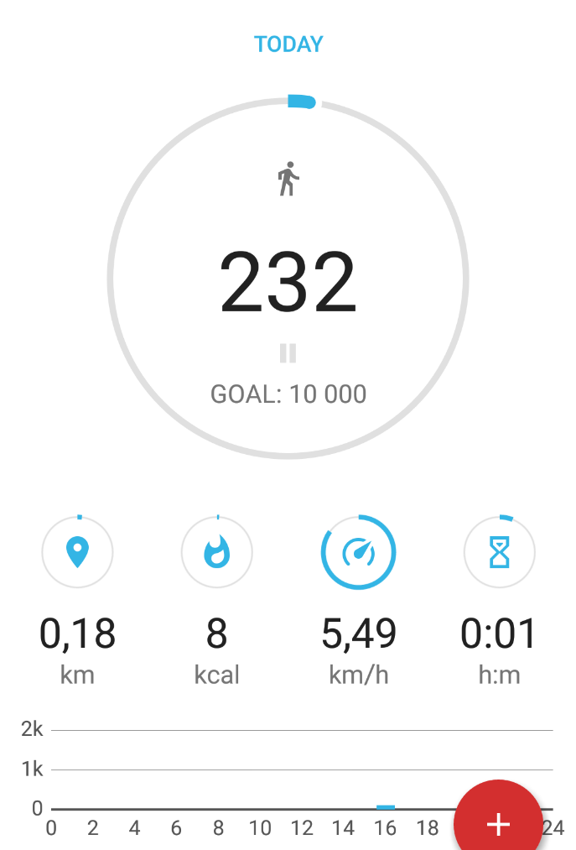

(Corusen LLC, 2019)

The home screen provides additional information, such as distance travelled during the day, calories burned, average walking speed, and duration of exercise – how long the user has been moving for. Below this information, the user can view activity over the past 24 hours. The bar graph represents steps taken during the past 24 hours.

Lower down on the home screen, a weekly view can be seen which shows more information when the user clicks the “More Chart” button.

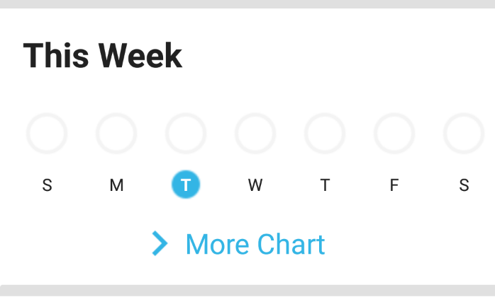

(Corusen LLC, 2019)

**Previous Data Chart**When pressed, the “More Chart” button opens up a window which shows historical data over the past day, week, month, or year. The user can select which data to show from a drop down menu (shown), such as steps counted, distance travelled, calories burned, or time spent exercising. The screenshot below shows the data for the week, and steps counted on their respective days.

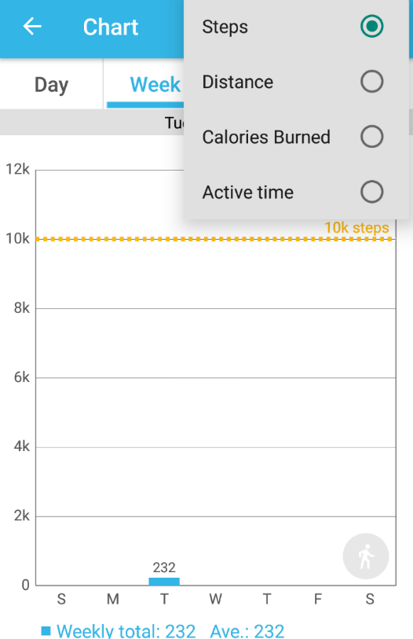

(Corusen LLC, 2019)

Totals and averages are also provided for the historical data shown.

**Home Screen – Continued**

The application provides fitness tips lower down on the home screen, which includes a “smart message” – this encourages the user to step up their daily walking if they have yet to reach their daily goal.

Below this is the history section, which provides an overview of the route taken using GPS. Travel time, distance, calories burned, and steps taken are also visible to the user. When the smartphone detects that the user is moving, it will add “activities”, which are recorded in this history log. If the user is not subscribed to the premium version, then they will have to add a new activity manually within the application.

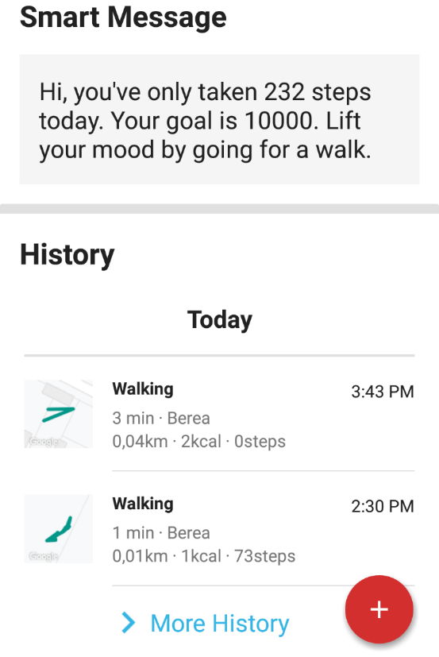

(Corusen LLC, 2019)

**Activity History**

When the user clicks the “More History” button, the application will display all historical data that is available. A full log of all activities will be displayed, which will be ordered by date. The user can easily track fitness progress using this feature.

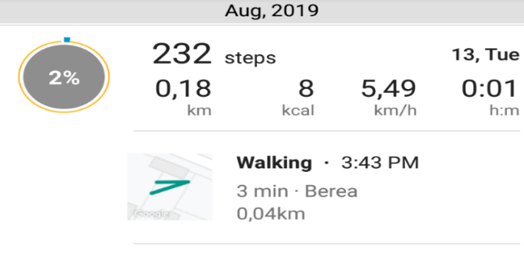

(Corusen LLC, 2019)

Activity history information is provided. The user can select an activity (such as a walking activity). Once they select an activity, a page containing detailed information is displayed (below).

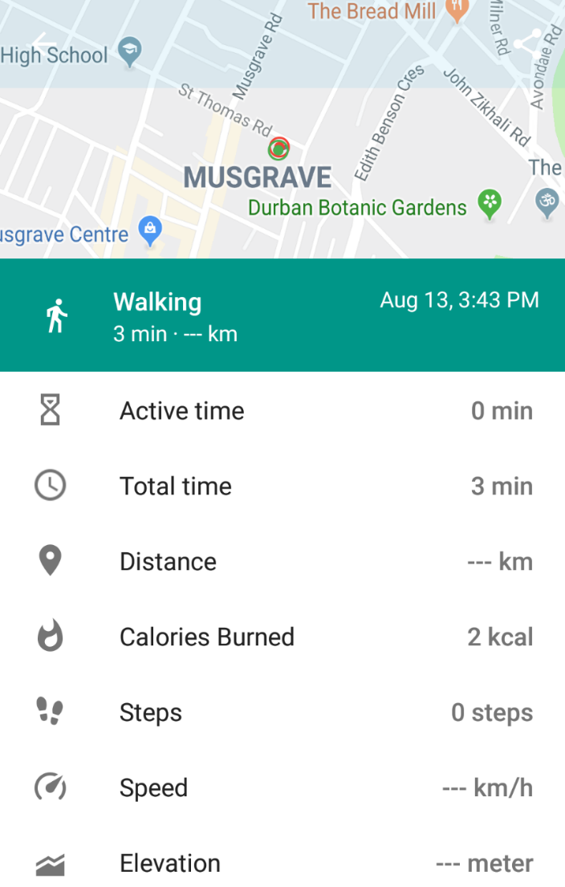

(Corusen LLC, 2019)

**Start Activity**

A user may start a new activity on the home screen by selecting the red “+” icon on the bottom right of the screen.

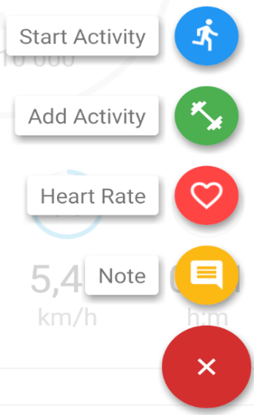

(Corusen LLC, 2019)

This will add a new activity to the fitness log, and present a status page to the user. It allows the user to determine how many steps they have taken, travel distance, and more.

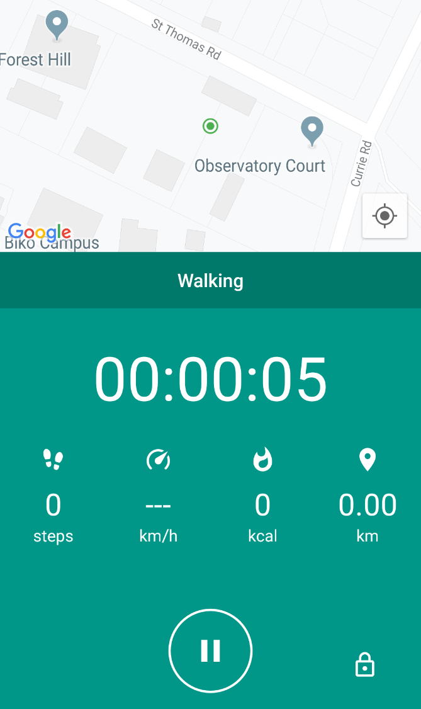

(Corusen LLC, 2019)

**Goals**

During the initial application setup, the user will be prompted to enter daily goal information, which can also be changed within the settings later on, along with other preferences. Below is a screenshot of the daily goals.

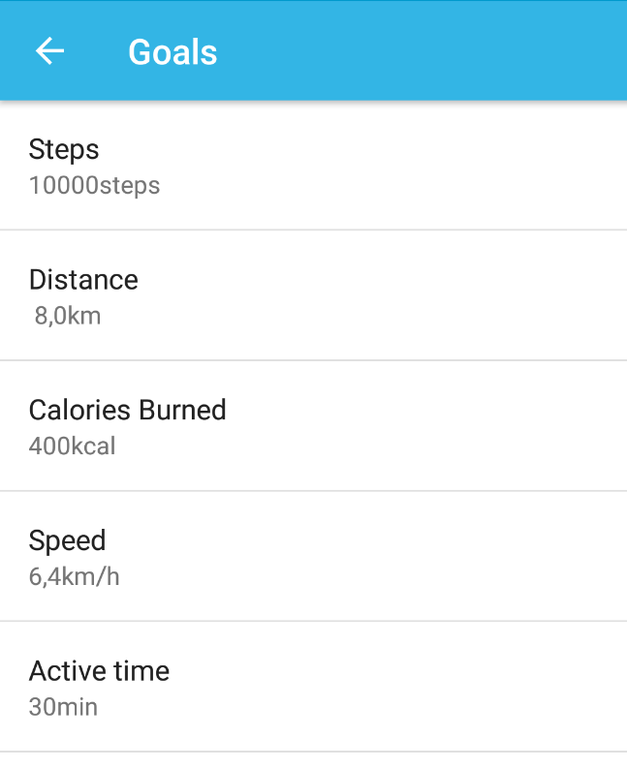

(Corusen LLC, 2019)

Personal information can also be edited within the application settings, as shown below.

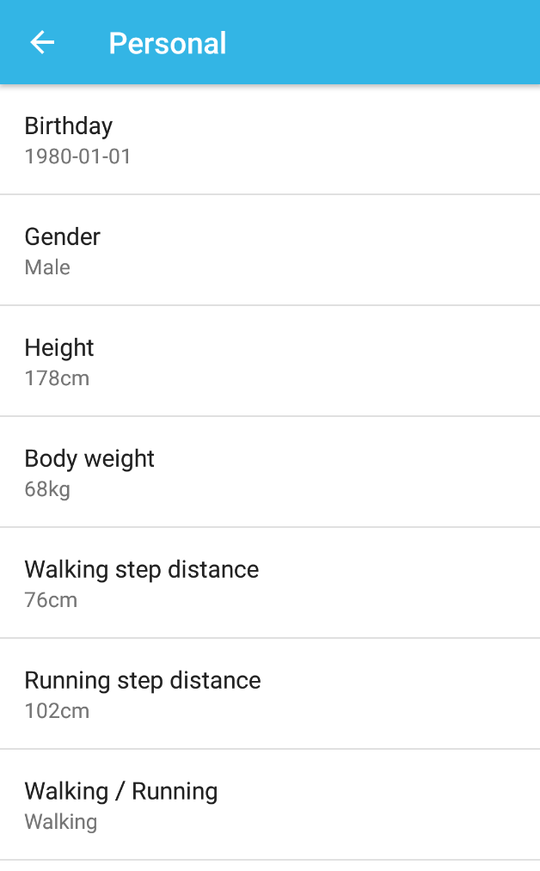

(Corusen LLC, 2019)

In addition to the features shown in the screenshots above, other notable features include the following:

* The ability for users to change from using Metric to Imperial units.
* Users can share daily performance logs via messages or email.
* Ability to backup all logs to Google Drive.
* Integration of 3rd party applications – Caloriecoin and MyFitnessPal.
* Ability to add daily notes, which can be viewed in the history log. (Corusen LLC, 2019)

This application provides a feature rich, and user friendly design, which can be easily used to track fitness of the user. It provides a few innovative features, such as keeping track of walking routes via GPS, and allowing simple note taking for each day. The application uses the accelerometer to track distance travelled, so it can therefore be used offline and even without signing up an account. (Corusen LLC, 2019)

### Application 2: Samsung Health – By Samsung Electronics Co., Ltd.

Overview of the application  
Samsung Health application offers many features, including a step counter, food calorie tracker, heart rate monitor, among other features. This application is available for free, however certain features are only accessible when the user enters their health insurance information. The health insurance information unlocks the ability for users to video call doctors. It is unfortunately only available in select countries. The application can also be used without signing up an account, which allows users to access basic functionality without internet or an account with Samsung. It is available on iOS App Store and Android Play Store, and can sync data with a Samsung account if signed in. (Samsung, 2019)

The user is able to set personal information such as gender, date of birth, height, and weight when setting up the application, which is used when assessing health and fitness. This can also be edited later on within the application settings. Physiological information is used to calculate step length, which is used when calculating distance travelled. It provides weekly summaries, programme history, personal bests, and rewards that accumulate from activities. (Choudhary, 2019)

Once the application has been set up, the user will be brought to the home page, which shows fitness information such as current step count for the day, and a diagram showing progress as a percentage of the current step count over a set goal. The user can change their daily step count goal by navigating to the “Steps” page, which is accessed by clicking the graph on the main menu. This allows the user to change their target step count for each day, and when changed it will reflect on the home screen diagram. The “Steps” page shows a step count for the current day in more detail, by showing distance travelled, and calories burnt. It also provides a graph showing step count over hours progressed in the day. (Choudhary, 2019)

Trends can be accessed by selecting the “Trends” menu button at the top of the “Steps” page. This shows average daily steps over days, weeks, and months. It provides insights into fitness progress of the user, by displaying current and historical data which has been collected by the application. This is beneficial to the user, as they can view their step count trends over the past few days, weeks, or months. (Choudhary, 2019)

Below the main step counter diagram on the main menu, the user can view the activity time for the current day, including calories burnt during this time, and distance travelled. When the user selects this home screen card, they can view more current and historical information. (Choudhary, 2019)

The user can add exercise sessions to their records by selecting an exercise type from the “Exercise” card on the home screen. This can be either running, walking, cycling, among others. When selected, targets can be set. For example, the user can set the distance target to 5 KM, and duration to one hour. This would provide valuable information for the user, as they can assess if their targets have been met during or after the exercise session. The application also displays a map, which shows the current location of the user and route taken during their exercise session. Once the activity has been started, an overview screen is displayed which contains information such as steps per minute, distance, and more.

When the user ends the exercise session, a detailed summary is displayed which contains information about the session. It contains duration, distance, average and total steps per minute, among other information. The user can also add notes and images to the session log. (Banks, n.d.)

Another key feature is the ability to track heart rate using the built in sensor on the phone or through an accessory such as Galaxy Fit or Watch. Trends can be analysed over time to determine overall fitness of the user. User weight can also be tracked similarly, which in turn calculates the BMI of the user. Calculations are completed by using physiological information stored on the user account, such as height, gender, etc. Weight can be entered manually or from accessories (such as connected scales). (Banks, n.d.)

The application also allows users to track how many calories they consume each day, by entering total calories for each meal, or browsing meals which are available online. When browsing meals online, the breakdown of nutrients are displayed, such as protein, carbs, etc. The user then sets the portion size and adds the meal to their health log, which can be accessed later to view trends. Water intake can be recorded, which allows the user to select how many glasses of water they have consumed during the day. (Banks, n.d.)

Another key feature of Samsung Health is its ability to track sleep either manually or from accessories such as Samsung Fit. The user enters the number of hours that they slept for, and a sleep quality rating. Trends can then be analysed over time to determine quality of sleep. (Soman, 2019)

Targets can be set for all tracking aspects of the application. For example, weight targets can be set and viewed at any time from within the application. It works much the same for other features, such as calorie intake, water intake, step counts, etc. This would be useful for the user to track progress over time for all these health aspects. (Soman, 2019)

The last key feature of this application is that when the user is signed up to a Samsung account, they can add friends to their account, create challenges, and share this information between users. It also provides comparisons between the average step count of the user and worldwide averages, and leaderboards to compare fitness with friends and family. (Choudhary, 2019)

Additional functionality can be accessed from the settings menu, including:

* Login/ signup to Samsung account: This will sync all data with your Samsung account, and enable additional features, such as “Together” functionality – enables account friends, challenges, and more.
* Units of measurement: Allows the user to choose between Metric and Imperial units when entering or displaying data.
* Notifications: The application can notify the user with weekly summary reports, completed challenges, workout detection alerts, etc.
* Accessories: The user can add connected devices, such as smartwatches, scales, and other compatible devices to the phone, so that Samsung Health can access data readings from these devices.
* Notification panel: The application can be set to show the current step count for the day on the notification panel.
* Detect workouts: The user can set the application to automatically detect workouts, or if they wish to set this manually they can disable this function.
* Lock app: The application provides data security in the form of a password, which can be enabled using this setting.
* Data Permissions: This application allows for 3rd party integration of other health applications, and permissions can be allowed or revoked in this setting.
* Download personal data: Samsung allows users to download all data that has been collected by the Samsung Health application.
* Erase personal data: Deletes all recorded information about the user.
* About: Provides version number.
* Help: Provides user documentation which is used to assist users. (Samsung, 2019)

#### Strengths and Weaknesses

Overall this application provides a large number of features, with some key strengths and weaknesses identified below:

**Strengths**

* The application is free to use, and there are no in-app purchases or advertisements. The user may access additional functionality by signing up to a Samsung account, which is also free. User data is synced with their account when signed in to their Samsung account. (Samsung, 2019)
* The user interface is easy to use, and navigation is clear. All functionality is provided on the home screen, yet it does not appear too busy. Settings are easily accessible, as they are not buried in sub-menus, unlike Accupedo Pedometer. (Samsung, 2019)
* Integration with accessories greatly improves accuracy and efficiency. Samsung Health allows users to gather information from wearable devices such as Samsung Fit and Wear, and also household items such as connected scales. Wearable devices can provide heart rate monitoring, step counting, and other such information, which Samsung Health will use. (Soman, 2019)
* Together mode allows users to invite friends to challenges, and compare progress via a leaderboard system. The user may also view overall progress compared with all Samsung Health users and compete in global challenges. (Soman, 2019)
* Built in heart rate monitoring using the phone flash and camera hardware. This feature allows users to monitor their heart rate within the application, using the phone or accessory such as a wearable device. The application can track vital signs of the user. (Soman, 2019)
* Provides food calorie intake monitoring, which is easy to use as it has been integrated with an online database containing many products from around the world. The user can simply search for the product, select a portion size, and add it to their record. (Soman, 2019)
* The application monitors activity including workouts automatically, even if the application has not been opened. It provides this functionality for free, unlike Accupedo Pedometer which charges a fee for this functionality.
* Provides free to use health and workout programmes. (Samsung, 2019)

**Weaknesses**

* Some features are only accessible in a few select countries. Video calling doctors is only available in the US, China, and Korea. Even within these countries, not all medical insurance companies have access to this feature. (Choudhary, 2019)
* Some aspects of the user interface are poorly designed. The “Discover” page provides information on products, but also sleep stories, meditation programs, and other featured applications. While this is valid information, it appears to be an afterthought in that it has all been placed in one page. It also does not have a dark mode. (Choudhary, 2019)
* Most features are primarily aimed at users who have smartwatches, and other connected devices. The application does provide functionality for users who do not use these devices, however it is limited. (Soman, 2019)
* Compatibility of 3rd party smartwatches and other accessories is limited, as this application has primarily been focused on Samsung products. Xi Band is not currently supported, along with a number of other devices. (Soman, 2019)
* Requires Samsung account to unlock functionality, unlike other applications that can use Google accounts. Many other applications will use a Google account to store information instead of their own account. (Choudhary, 2019)
* It does not have a dedicated website where the user can sign in and track fitness data. (Soman, 2019)

#### Innovative Features

The application provides a few innovative features, including the following:

* Together functionality allow users to set up challenges and compete with friends and family, which encourages competitive users to exercise more often. Because the application works on iOS and Android, users are more likely to have access to this feature.
* The application will measure heart rate of the user by using the built in phone sensor or wearable device. The heart rate information is stored in the user log, and trends can be accessed and viewed over days, weeks, or months.
* A security lock prevents unauthorised users from accessing personal details. The application has a built in security feature, which allows users to set an application password in order to secure their personal details.
* Integration with accessories provides an easy way for the user to track fitness progress. For example, the application can retrieve weight from connected scales, and heart rate and step count from smartwatches. (Choudhary, 2019)

#### Screenshots

**Home screen**

When the application loads, the user will be presented with a home screen, which shows the current step count for the day, along with the daily goal. Below this is the active time section, which shows the time duration of exercise for the day, calories burnt, and distance travelled.

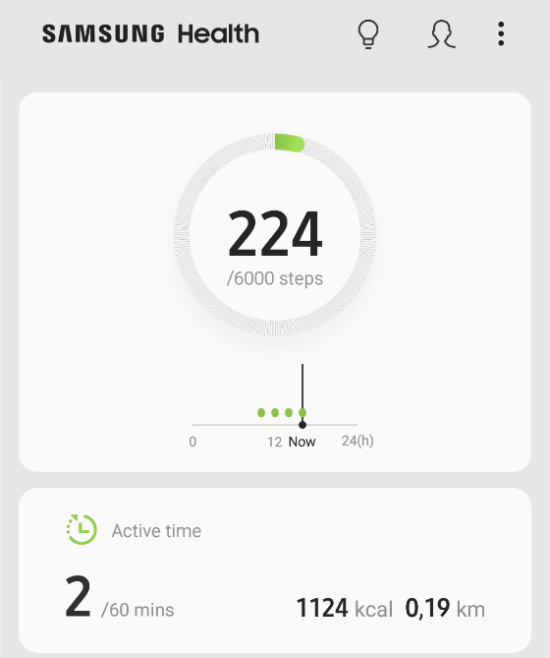

(Samsung, 2019)

Scroll down on the home screen, and workout sessions can be created on the “Exercise” card. Previous sessions can also be viewed if the “Recent workouts” button is selected.

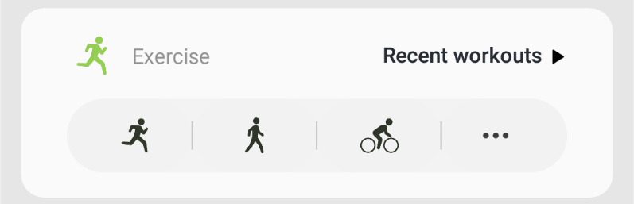

(Samsung, 2019)

Scroll down further and additional information is shown, including food calorie intake per day, sleep duration and quality, weight, and heart rate monitoring. The user can select “Add” on the food card to add a new meal to the history.  
The user can include sleep information such as duration by selecting the “Record” button on the sleep card.  
Current weight can be entered by selecting the “Record” button on the weight card. Weight can be entered manually or retrieved from a connected scale.  
Heart rate can be measured using the phone sensor or through a connected wearable device such as a smartwatch. This is accessed when the user selects the “Record” button on the heart rate card.

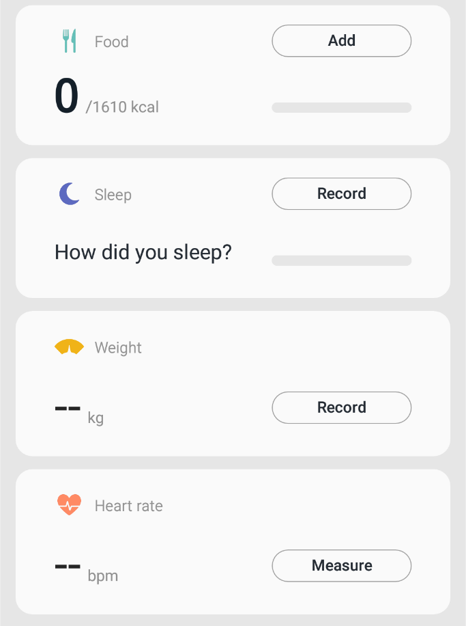

(Samsung, 2019)

Lastly, the user can enter how many glasses of water they have consumed during the day.

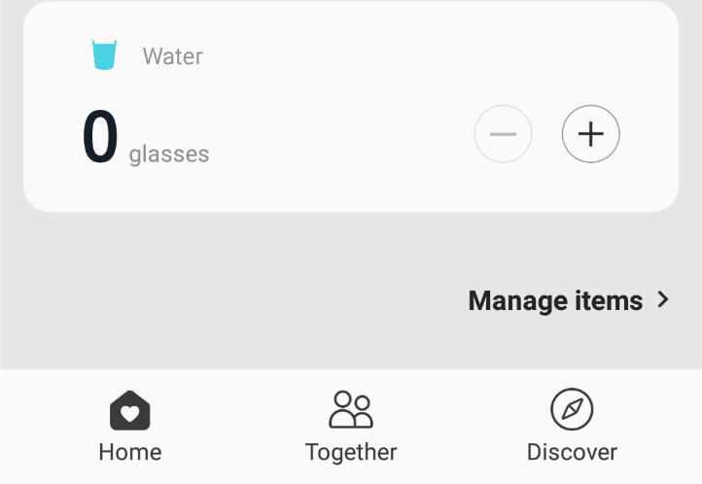

(Samsung, 2019)

**Steps**

When the user selects the step counter diagram at the top of the home screen they are brought to a more detailed view, which shows two tabs (Track, and Trends). Track provides step counts for the current day only, and Trends provides historical data over days, weeks, or months.

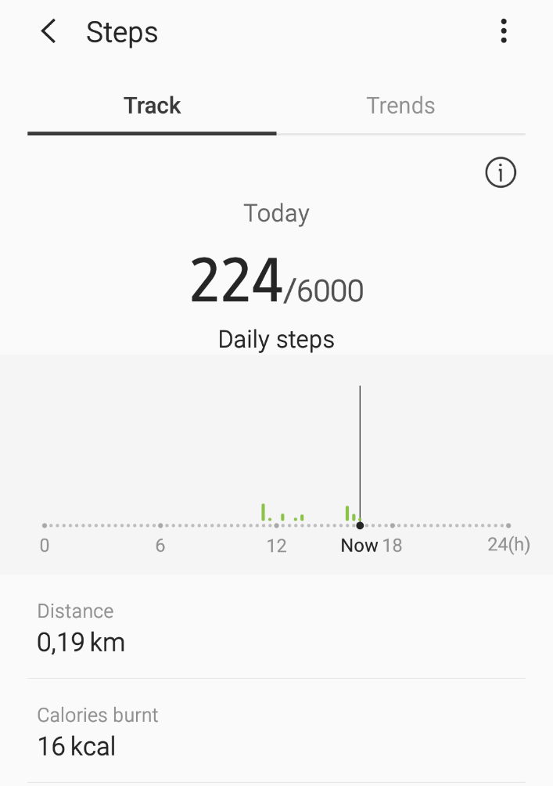

(Samsung, 2019)

When the user selects the “Trends” view, detailed historical data is shown.

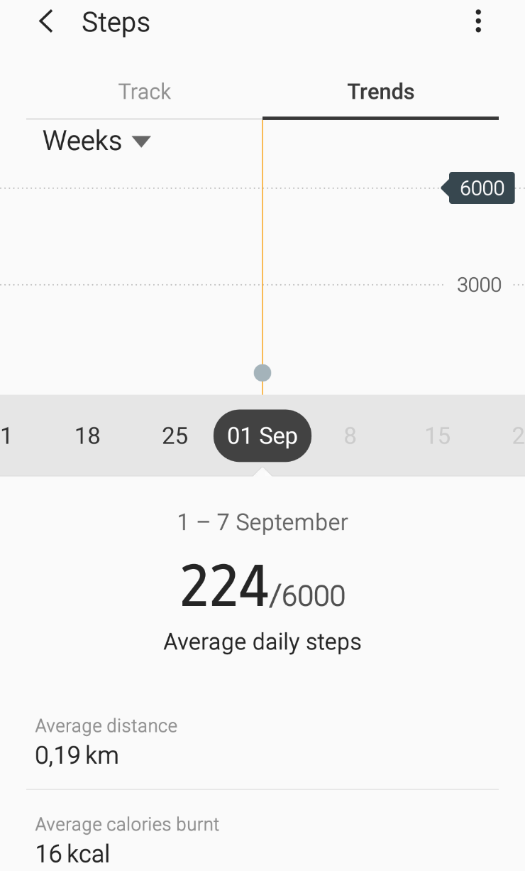

(Samsung, 2019)

Distance and calories burnt (average for trends) are shown on the pages to provide further details for the user. The daily goal is also displayed on both pages to show progress (how close the user is from their set target).

**Step count goal**

The user can set a step count goal by selecting the three dots (menu) from the previous screen and selecting “Set target”. This will allow the user to set a daily step count goal (shown).

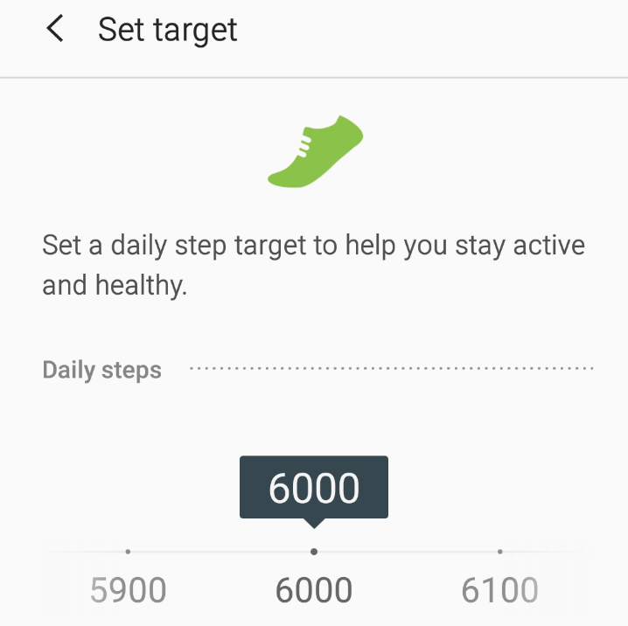

(Samsung, 2019)

**New Activity**

The user is able to set up a new activity, which will then record steps taken and distance travelled. It will also provide burnt calorie count, and average step count per minute. Once the user clicks “Start” it will start recording the step count and provide an exercise overview.

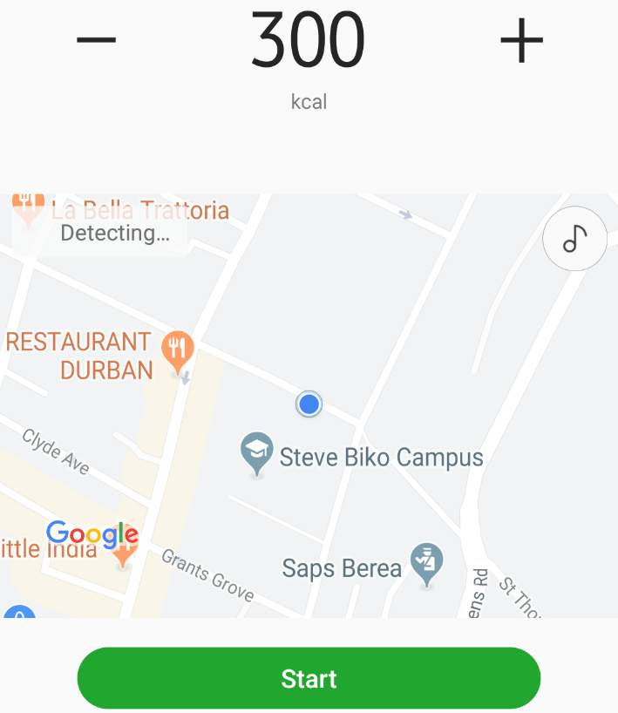

(Samsung, 2019)

**Heart rate monitoring**

Another key feature of this application is that it allows users to measure their heart rate using the built in phone sensor, or an accessory. This information is then stored on the user account and is accessible as trend data (much like the step count trends page).

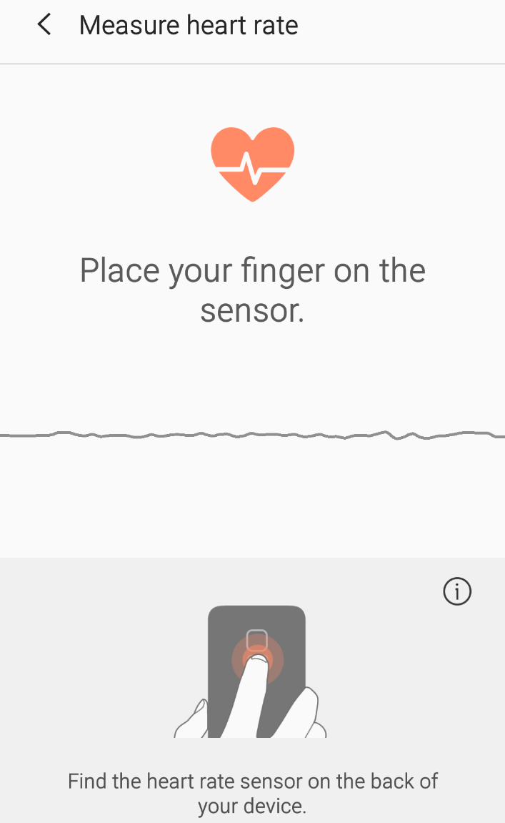

(Samsung, 2019)

In addition to the features shown in the screenshots above, other notable features include the following:

* Ability to set an application password, which secures your personal details.
* The user can set target goals for most aspects of the application, including weight, food calorie intake, and water intake.
* Trends for all health aspects are available, such as heart rate, food calorie intake, and so on. Only the trends page for the step count was shown in the screenshots, but it is available for all other aspects.
* The application has a page which lists all connected devices, such as fitness trackers, scales, etc. The user may connect new devices on this page.
* Leaderboards and challenges are available in the “Together” page, along with invited friends.
* Discover page shows a marketplace for smartwatches, and other such devices, along with exercise and meditation programmes. (Samsung, 2019)

Overall, this application provides many functions, which can be accessed from a well-developed user interface. It provides accurate step counting, and a host of features which are all free to use. Some features such as heart rate monitoring are usually implemented in separate applications, but Samsung Health has provided this functionality within one application. It strives to provide all functionality that a user may need within a single health application. (Samsung, 2019)

### Application 3: Pedometer Step Counter – By Leap Fitness Group

#### Overview of the application

Pedometer Step Counter provides an easy to use Android application which tracks the step count of the user, along with calories burnt, and distance travelled. It requests physiological information from the user, which is used to determine step length and BMI. Step length can be fine-tuned within the settings to provide more accurate results. The application is free to use, however it does contain advertisements. The user can pay a once off fee to remove these advertisement, and a subscription fee for workout plans. (Softonic, 2019)

The application allows users to sign in to their Google account, which will allow for automatic backups and access to Google Fit devices which are linked to their accounts. These features are free to use, and require no subscription fee. The application can be set to provide daily reminders, and current step count and calories burnt during the day, within the android notification centre. (Leap Fitness Group, 2019)

This step counting application does not provide a GPS route feature, which means that it uses very little battery life, and can be used without mobile data. The user can edit the pedometer sensitivity and step length within the application settings, further improving accuracy of the data collected. (FreeAppsForMe, 2019)

It allows the user to enter a step count goal, which is displayed on the main menu, much the same way as the previous two applications. The main menu also provides distance travelled (calculated using an algorithm), calories burnt (using physiological characteristics), and the duration of time that the user has exercised for. The user may also pause step counting temporarily if they wish to do so, by pressing a button on the main screen. (FreewareFiles, 2019)

A drop down menu on the home screen provides access to an “Achievements” page, which displays progress of the user. They reach milestones after increasing daily step count, or distance travelled. They also receive achievements if they complete workout sessions each day for a set time duration. Achievements can be shared with most applications, such as messages, email, and more. (Leap Fitness Group, 2019)

The menu also provides access to a “Timeline” page, which displays step counts, calories burnt, active time, and distance travelled for each day of the past week. The total step count for the week is also visible on the page, and the user can delete records from the historical data using a delete function (they can also do this for the current day on the home screen). (Leap Fitness Group, 2019)

A more comprehensive fitness report can be found in the “Report” tab at the bottom of the application user interface. This will show achievements, and more detailed daily, weekly, and monthly reports. These reports are generated for step counts, calories burnt, time spent exercising, and distance travelled. The data is represented with the use of a bar graph, which makes analysis much easier for the user. (Leap Fitness Group, 2019)

The application provides health tracking, but only includes water intake, weight, and BMI tracking. This isn’t as comprehensive as Samsung Health, but well implemented. Glasses of water can be added manually to the record, and glass capacity can be edited (unlike Samsung Health). (Leap Fitness Group, 2019)

Weight can be added for any day, and is displayed on an easily readable line graph. Targets for weight and BMI cannot be set, but reminders for drinking water can be set. The application allows the user to change units from metric to imperial, and weight is automatically converted to the right value. (Leap Fitness Group, 2019)

BMI is generated using physiological values, such as weight and height, and can be viewed on an easily readable diagram, which shows the underweight, normal, and overweight ranges. (Leap Fitness Group, 2019)

The last key feature of the application is that users may sign up to fitness plans (accessed from the home screen), which will allow them to follow a set plan that aims to increase their fitness, prepare them for a sporting event, or other such occasions. These subscriptions can be paid monthly or lifetime payments are available. Fitness plans allow for reporting, which helps the user to view progress as they complete certain milestones. This includes distance travelled, calories burnt, and time duration. The plans set out workouts every day for a set number of weeks, depending on the plan that the user has subscribed to. (Leap Fitness Group, 2019)

The plans section allows users to integrate the health application with music applications, such as Deezer. It will provide coach tips, and feedback such as time duration and distance travelled after set milestones have been met, which can be edited within the settings. Reminders can also be set to remind the user to complete daily exercise that the health plan has recommended. (Leap Fitness Group, 2019)

The health application provides support for Google Fit devices, which can pass step counts to the application. This provides a more accurate way of recording exercise. (Leap Fitness Group, 2019)

Additional functionality can be accessed from the “More” page, including:

* Lifetime Totals: Provides total calories burnt, steps taken, and distance travelled. These are accumulated from when the user first installed the application.
* Achievements: Loads the achievements page in the application.
* Step Goal: Sets daily step goal for the user.
* Sensitivity: Allows the user to change the pedometer sensitivity for a more accurate result. Higher sensitivity will detect steps more frequently when smaller movements occur.
* Weight: Sets the current weight of the user. Used when calculating BMI and calories burnt.
* More settings: Allows the user to set further preferences and enter physiological information, such as:
  + Gender
  + Step Length
  + Metric & Imperial Units – can select either one.
  + First day of the week
* Backup & Restore: Uses Google Drive to backup or restore user information.
* Google Fit: Allows users to connect smartwatches and fitness trackers to the application.
* Notification Bar: Shows step count and calories burnt in the Android notification centre when enabled.
* Drink water (On/ Off): The user can disable water intake tracking, along with notifications for this aspect.
* Voice Options: The application provides coach feedback, and allows the user to change coach voice with this setting, and also language spoken.
* Reminder: This sets daily reminders, which can repeat on particular days of the week.
* Language options: Sets text language of the application.
* Instructions: Provides user documentation.
* Feedback: Allows the user to enter any feedback that they may have.
* Remove ads: The user can pay a once off fee to remove advertisements (banner and full screen).
* Privacy policy and version number: Provides application information. (Leap Fitness Group, 2019)

#### Strengths and Weaknesses

Overall this application provides a large number of features, with some key strengths and weaknesses identified below:

**Strengths**

* The health application is free to use, but does contain advertisements. The user can pay a once off fee to remove these advertisements. Subscriptions also cost a monthly fee, but only unlock fitness programmes, which are optional.
* Uses a Google account to backup and restore user information. It does not require the user to sign up to their own account for access to these features. This provides an easy way for users to access these features. Users do not even have to sign in to use the basic features of the application.
* Does not require a cellular connection or GPS signal, as it does not provide map functionality. This reduces battery and data usage considerably.
* Excellent user interface design. Navigation is clear, with a high level of affordance. The application does not contain unnecessary features and pages which often lead to a more complex user interface.
* Can be integrated with Google Fit devices, such as smartwatches and fitness trackers. The user can also use the integrated accelerometer.
* Provides a setting to change pedometer sensitivity, unlike the previous two applications which did not.
* Ability for the user to change user interface language (text and audio). They can also change audio type to a different voice.
* This health application provides a coach ability, where a plan is set up which the user can follow. This is a paid feature, which can be purchased once off or as a subscription. (Leap Fitness Group, 2019)

**Weaknesses**

* The application provides no GPS tracking, unlike the previous two applications. GPS tracking would be a nice addition, as it would allow users to view the route that they take when exercising.
* High subscription costs for health programmes. This is a useful feature, but is rather expensive when compared to the competition.
* Does not provide support for accessories such as connected scales, or heart rate monitors.
* Functionality is limited, as the application does not provide heart rate, or calorie intake monitoring. It is essentially a pedometer, and nothing more.
* Does not provide the ability for users to add notes or images to their health log, which we will have to implement in our solution.
* The application displays many advertisements on its user interface. When navigating through the application, full screen advertisements are displayed. Banner adverts are also displayed above the navigation bar. (Leap Fitness Group, 2019)

#### Innovative Features

The application provides a few innovative features, including the following:

* It allows the user to set the pedometer sensitivity, which further increases the accuracy of the step counts. This was not available in other applications that were researched. The user can fine-tune this setting to provide a much more accurate activity result.
* Provides a coach feature via an in-app subscription service. This service will provide training programmes, which include audio walkthroughs and guides. The virtual coach will walk the user through each day for a number of weeks in order to complete the exercise plan.
* The user can change text and audio language within the application settings, unlike other applications which were researched. The user may also change the type of voice used by the virtual coach.
* Achievements section encourages the user to increase exercise duration and frequency by notifying the user once they reach certain milestones. This includes distance travelled, step count, and number of days that they have exercised for. (Leap Fitness Group, 2019)

#### Screenshots

**Home Screen**

When the application first loads, the user will be presented with a home screen. This screen contains information including the current step count for the day, daily goal, distance travelled, calories burnt, and active time spent exercising. The main step count diagram shows daily progress by filling up the circle with green “liquid”.

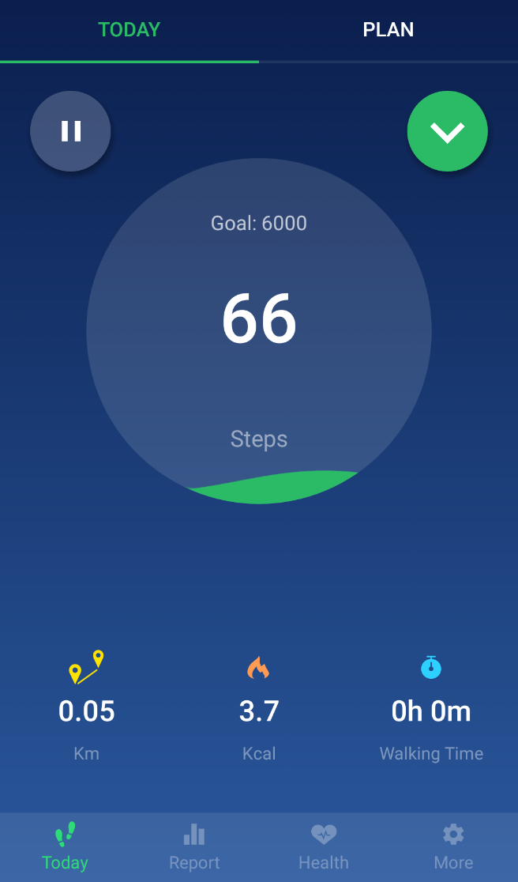

(Leap Fitness Group, 2019)

The user can pause step counting temporarily by pressing the “||” pause button, or show the menu by selecting the green arrow. There is also a menu at the bottom of the screen, which brings the user to either the “Today” (current) page, “Report”, “Health”, and “More” pages. The user can select between “Today” and “Plan” at the top of the screen. The “Plan” page shows the coach subscription services which are available. It also shows progress and notifications if the user is currently signed up to these services.

When the user selects the green menu icon, the following buttons are presented:

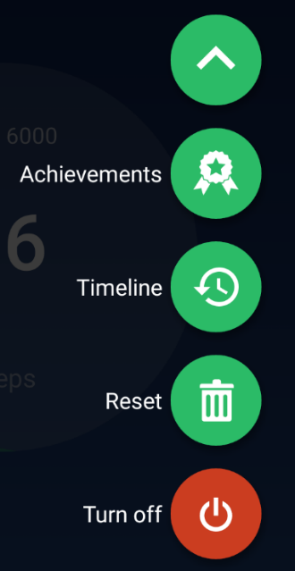

(Leap Fitness Group, 2019)

* “Achievements” brings the user to the achievements page.
* “Timeline” brings the user to the historical data page, which shows weekly records.
* “Reset” will reset the step count for the current day.
* “Turn off” closes the application.

**Report**

When the user selects “Report” from the lower menu bar, the user is brought to a page which provides historical data. This contains step counts, calories burnt, active time, and distance travelled. The user can select either of these views, and the data will show on the bar graph.

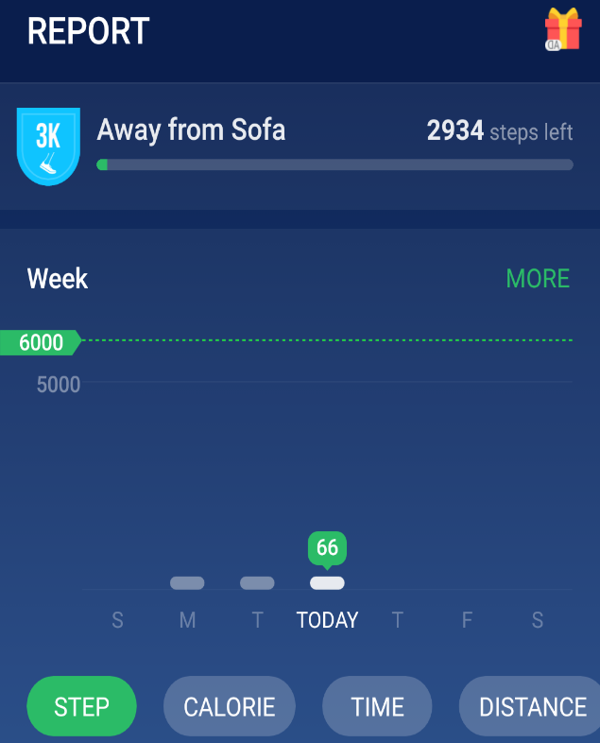

(Leap Fitness Group, 2019)

If the user were to scroll down on this page, historical data will be provided for daily, and monthly time durations too. The data is displayed in the same way as in the previous screenshot. If the user were to select the graph, it will simply expand the graph view, providing an easy way for the user to view the historical records.

**Health**

The user can select the “Health” page from the lower menu bar, and will be brought to a page which contains information such as daily water intake, weight trends, and BMI information.  
The user may select the green “+” on the glass to add it to the health log. The “More” button presents a screen that allows the user to set a daily water intake goal, glass capacity, reminders, and change units from metric to imperial.  
The weight section provides weight trends over the past month, and allows users to enter their weight for any day when they select the “Add” button.

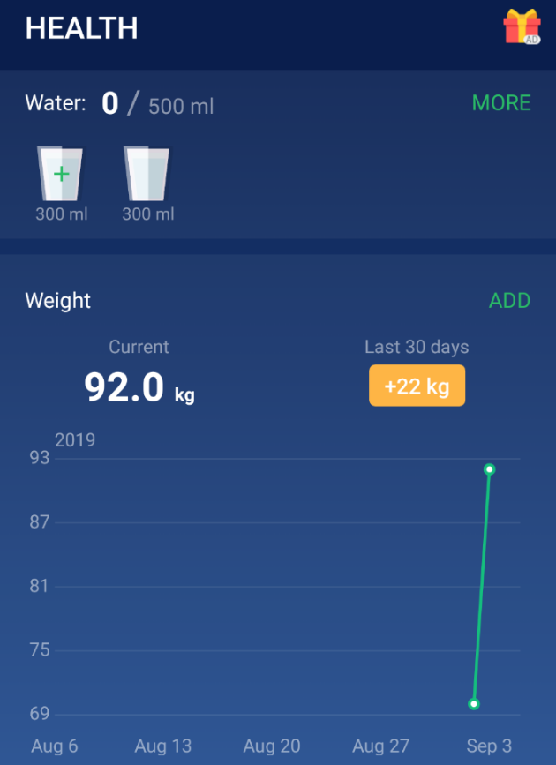

(Leap Fitness Group, 2019)

When the user scrolls down, a BMI diagram is shown. The application uses physiological information to calculate BMI and determine if the user is underweight, normal, or overweight.

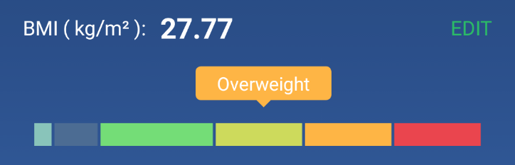

(Leap Fitness Group, 2019)

**More**

If the user selects the “More” button from the lower menu bar, a screen is presented which allows the user to complete the following actions:

* View lifetime goals, and go to the “Timeline” page.
* View Achievements
* Set step count goal, which will then be displayed on the main menu.
* Set pedometer sensitivity, which affects how movement is registered as a step.
* Set current weight, which is used during BMI and other such analysis.
* More settings presents a page which allows the user to change the following:
  + Set user gender.
  + Set step length – user can change this to improve accuracy.
  + Change units from metric to imperial.
  + Set first day of week (default is Sunday).

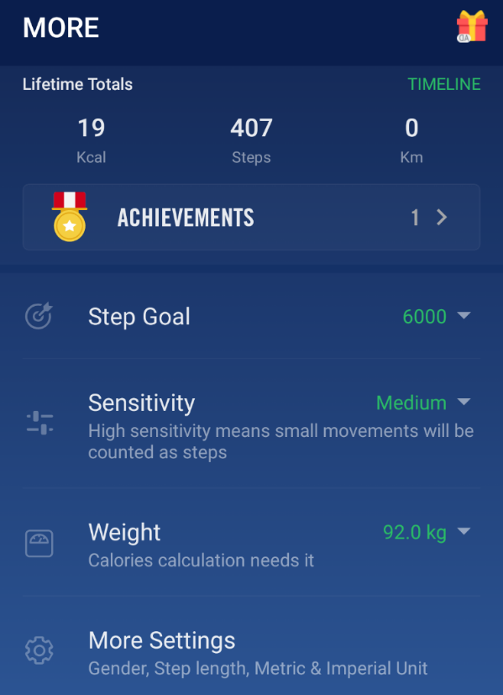

(Leap Fitness Group, 2019)

Lower down on the same page, additional settings are provided:

* Backup and Restore to Google account, which will backup user information to their Google account.
* Google Fit is used to connect to fitness trackers and smartwatches.
* Notification Bar allows the user to enable or disable step count notification.
* Drink Water can be enabled or disabled. This will simply remove this from the user log and will not notify the user when they should drink a glass of water.
* Voice Options allow users to change the voice of the coach and other narration.
* Reminder allows users to either enable or disable reminders, and set when they receive them.
* Language options allows users to change the text language in the application.

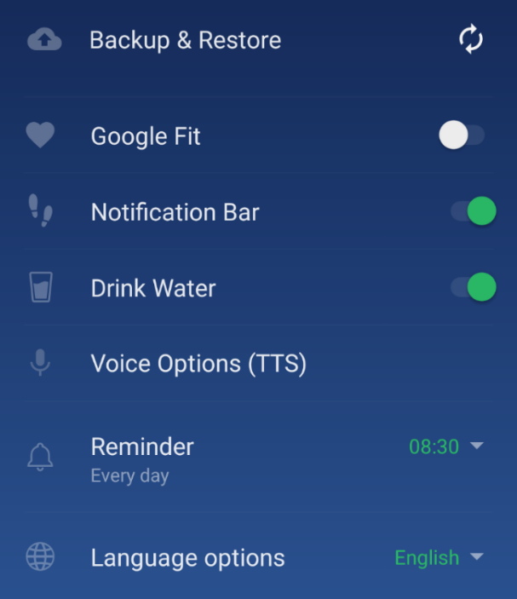

(Leap Fitness Group, 2019)

**Timeline**

When the user selects the “Timeline” button from the home screen menu, or from within the “More” screen, a page is presented which provides daily logs of fitness information. It contains daily step count, calories burnt, active time, and distance travelled. It also provides a total step count for the week. The user may select the trash can button, and it will allow them to select records which will then be deleted from their record.

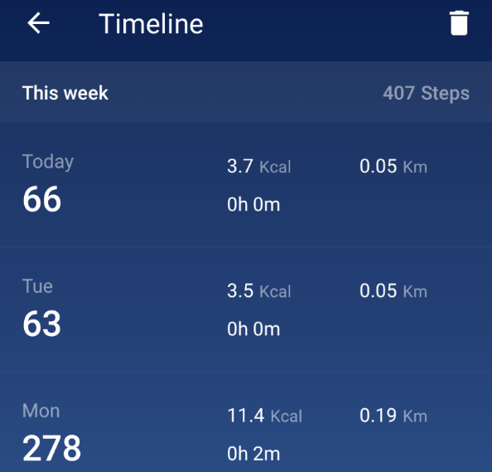

(Leap Fitness Group, 2019)

**Achievements**

The user can access this screen from the main screen menu, which presents the user with achievements that they unlock once they reach certain milestones.

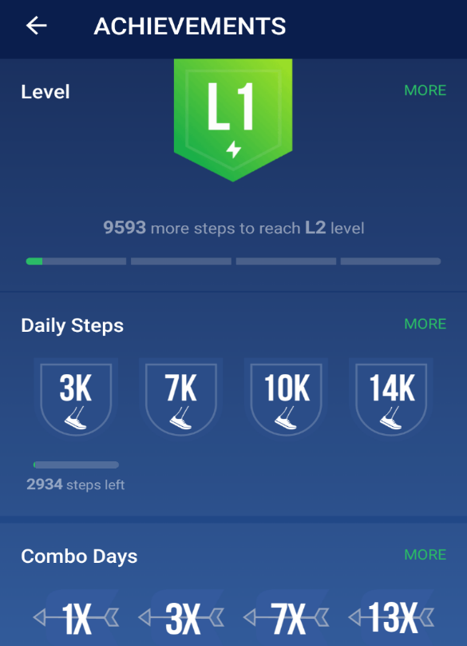

(Leap Fitness Group, 2019)

**Plan**

The “Plan” screen provides fitness training exercises, including virtual coaching. The user must subscribe to a fitness plan, which can be paid for either monthly or as a once off fee.

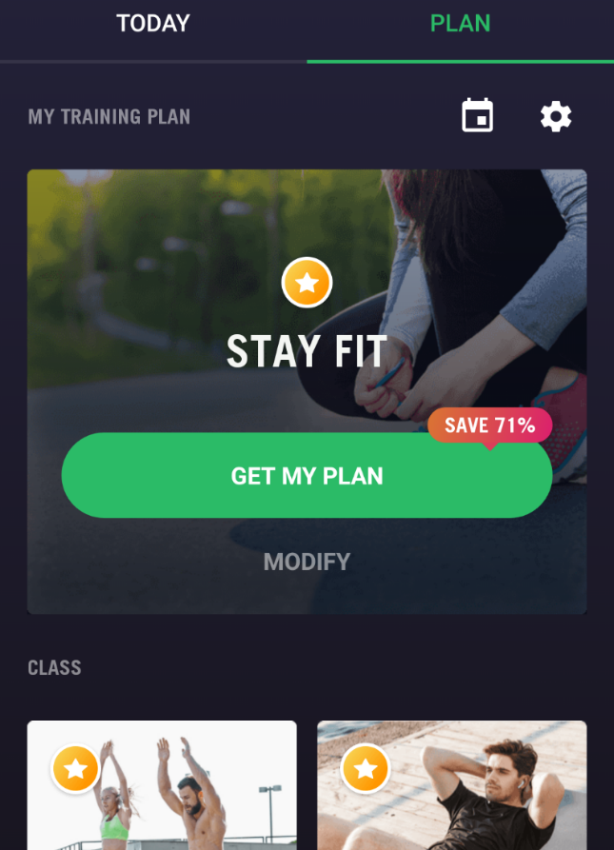

(Leap Fitness Group, 2019)

## Comparison of Applications

|  |  |  |  |
| --- | --- | --- | --- |
|  | **Accupedo** | **Samsung Health** | **Pedometer Step Counter** |
| **GPS Support** | ✓ | ✓ | ✗ |
| **Monitors Food Calorie Intake** | ✗ | ✓ | ✗ |
| **Monitors Water Intake** | ✗ | ✓ | ✓ |
| **Monitors Sleep Quality and Time** | ✗ | ✓ | ✗ |
| **Monitors Heart Rate** | ✗ | ✓ | ✗ |
| **Free to Use** | ✓ | ✓ | ✓ |
| **Advertisements Present** | ✓ | ✗ | ✓ |
| **Automatic Detection of Workouts** | ✓ | ✓ | ✓ |
| **Integration With Accessories** | ✓ | ✓ | ✓ |
| **Can Take Pictures of Exercises and Food** | ✗ | ✓ | ✗ |
| **Does Not Require Use of Account/ Can be Used Offline** | ✓ | ✓ | ✓ |
| **Can Set Step Length Manually** | ✓ | ✗ | ✓ |
| **Can Set Pedometer Sensitivity** | ✗ | ✗ | ✓ |
| **Backs Up Data to Google Account** | ✓ | ✗ | ✓ |
| **Provides Workout Guides and Tips** | ✗ | ✓ | ✓ |

**Comparison of the three applications (continued):**

Each application provides basic functionality which supports step counting using the built in accelerometer or external accessory. However, there are a number of unique features which differentiate the three applications. Accupedo is primarily focused on step counting, and does not provide monitoring of any health aspects such as food calorie intake, and water consumption. It also does not provide any monitoring of the vitals of the user, such as heart rate, and more. Samsung Health provides the most functionality of all three applications, by monitoring user vitals, including heart rate either from the device sensor or from accessory devices. Samsung Health also tracks calorie intake and water consumption throughout the day. In comparison, Pedometer Step Counter does not monitor user vitals, or calorie intake. It will however monitor water intake and remind users to drink water throughout the day with the use of notifications. (FreeAppsForMe, 2019)

Samsung Health will monitor sleep quality and time, with the use of Samsung wearable devices or the user can enter duration and quality rating manually. In comparison, Accupedo and Pedometer Step Counter applications do not provide such functionality. They are mostly focused on the pedometer, and do not provide an overall fitness solution. This is most apparent when reviewing application settings. Samsung Health does not allow its users to modify step length and pedometer sensitivity. When these two settings are fine-tuned to best suit the user, the results become more accurate. Samsung is motivating its users into purchasing a compatible smartwatch or fitness tracker (which happens to also be manufactured by Samsung) in order to increase accuracy. (FreeAppsForMe, 2019)

Another key aspect which has been identified is the use of GPS and maps within these three applications. Accupedo and Samsung Health will maintain logs of routes and elevation, so that the user can review past workout sessions. This is however not possible in the Pedometer Step Counter application, as it does not provide GPS and map services. It only records step counts, along with other such metrics. An important aspect to note is that all three applications base distance travelled on an algorithm, and not GPS. Even the applications which have implemented GPS functionality still use the pedometer, along with step length to calculate distance travelled. There are both advantages and disadvantages to this approach. The advantage is that it can be used without an internet or GPS connection, but the disadvantage is that it is less accurate than GPS. (FreeAppsForMe, 2019)

Users can connect accessories to all three applications, but there are some significant differences between capability. Samsung Health provides support for mostly Samsung devices, but the application can retrieve information from many devices. Devices include scales, fitness trackers, smartwatches and a host of other devices. Accupedo and Pedometer Step Counter applications are much more limited in their capability, as they can only retrieve step counts from connected devices. (FreeAppsForMe, 2019)

Automatic workout detection also differs between applications. Accupedo will provide this functionality, but only for premium subscribers. Samsung Health and Pedometer Step Counter provide this for free. All three applications will track step count automatically, even when closed, but workout detection is different. Workouts are individual sessions, in contrast to the overall daily step count. (FreeAppsForMe, 2019)

Samsung Health is unique in that it provides functionality for taking pictures during workout sessions. Accupedo and Pedometer Step Counter do not provide such functionality. Samsung Health with store these images in the user log, and can also include notes. After an exercise session, the user may add images and a note to the record before it is stored on the Samsung account or locally on the phone. (FreeAppsForMe, 2019)

Accounts is another key aspect that must be compared. Samsung Health is unique in that it will not allow the user to sign in using their Google account. They must use a Samsung account, which will then store all personal information and record data. Accupedo and Pedometer Step Counter allows users to sign in with their Google account, which will hold backups, records, and user information. All accounts are however free, so this may impact the user minimally. The only exception is that Google accounts allow for easy pairing with accessories such as Google Fit devices. (FreeAppsForMe, 2019)

Workout guides, tips, and virtual coaches are available in Pedometer Step Counter. Some functionality is available in Samsung Health such as health tips and guides, however Accupedo provides none of this functionality. Pedometer Step Counter is heavily focused on this aspect, and provides comprehensive fitness guides, tips, and entire virtual coaches which assist the user in becoming more fit. Exercise for each day, for the duration of many weeks are planned during these routines. (FreeAppsForMe, 2019)

Even though there are many differences among these applications, there are some similarities. All applications are free to use, and do not require the user to sign up/ in to their accounts. They all provide step counting and daily goals, and are represented on the home screen using diagrams that are easy to read. All provide basic functionality that is easy to navigate and use. (FreeAppsForMe, 2019)

## List of Features to Implement:

* **Login/ Sign Up:**  
  The user must be able to sign up an account and log in to the application in order to view their personal information.
* **BMI:**  
  The user should be able to enter their weight, and height, and the application will calculate BMI for the user.
* **Step Counting:**  
  Counts user steps using the built in accelerometer, and calculates distance travelled and calories burnt using algorithms.
* **Weight Monitoring:**  
  The application will prompt the user for their weight, which can be input each day. This will allow the user to view weight trends over time.
* **Daily Goals:**  
  Allows the user to set daily step count goals, which are shown on the home page, as a percentage of current step count over daily goal. I would use a diagram to depict progress of the user. The user should also be able to set weight targets in a similar way.
* **Ability to take pictures of meals and exercises:**  
  The user must be able to take pictures of food and exercises within the application. The pictures must be stored chronologically, for each day.
* **Unit Conversion:**  
  The application will allow the user to set units from imperial to metric, or vice versa.
* **Personal Details:**  
  The physiological details such as weight, height, and age will need to be stored and maintained on the database. The user should also be able to edit this information later on within the settings menu.
* **Fitness Log:**  
  The user must be able to view step counts for previous days, and trends. The should be able to do the same for weight.
* **Erase Data:**The user should be able to delete all their personal details from the application, when a button has been selected in the settings menu.
* **Erase Daily Step Count:**The user should be able to erase the step count for the current day. This would also delete associated information, such as distance travelled, etc. (The Independent Institute of Education (Pty) Ltd, 2019)

## Conclusion

The research phase of development has provided insights into three applications which are currently available on the Google Play store. All features of the applications were assessed, and compared with each other. This provided a great way of generating a list of features which I would like to implement for our task two and three submissions. The three applications were similar in that they were all pedometer applications, however they each had unique features which set them apart from the competition.

With this research completed, a design document will be generated which will use key features identified during research. These include step counting using the built-in accelerometer on the phone, among other features. By completing research into these applications, it has also helped to identify strengths and weaknesses of the applications. It was beneficial to understand those aspects before creating my own health application. Weaknesses can be addressed and a solution could be made to resolve these flaws or inefficiencies. By identifying strengths of the applications, I would be able to replicate or draw inspiration from some of the well-liked features in my own submission.

Research has also provided a way for us to compare user interface design, and to determine how we would best implement our user interface in the application. The screenshots section, which provided images of the user interface, and descriptions of their content was beneficial as we gained insight into how these three application were developed, and how we could improve or replicate their designs.

A comparison section further highlighted the differences between these three health applications, which assisted us in understanding which features we may want to implement in our solution. This list provided in the previous section was based on feature lists of all three applications. Taking some key functionality of these three applications, and a few innovative features which aim to set us apart from the competition, will help us to better understand what we must implement for our task two and three submissions.

# Design (Part B)

## Introduction

As part of our OPSC7311 module we have been tasked with developing a fitness tracking Android application, with a primary focus on step counting, and weight analysis. In order to complete this task, we have researched a number of currently available Android applications in the previous section, in order to gain insights into how others have designed and developed fitness trackers for the Android platform. The next step will be to take these insights and develop a project plan. The project plan will contain implementation details, such as a list of features to be implemented, user interface design, navigation details, a data listing of all the data that the application will process, and a document that sets out deadlines and milestones for the project. (The Independent Institute of Education (Pty) Ltd, 2019)

This documentation will ensure that the development of the application is progressing at the correct pace, while ensuring that requirements are being met. It also ensures that tasks are being completed sequentially or in the correct order. During development, this document can be used to assess progress. A few key aspects have been identified, and will be explained in the following sections.

Firstly, before we can start designing the application user interface, we must know which features are to be included in the final project. The research phase helped to determine which features could be implemented in our solution. The assignment question paper sets out application requirements, which will be followed when implementing the solution. Any additional innovative features, which have been identified form research, will also be included if possible.

After a list of requirements has been identified, which will include both innovative features and required functionality, a user interface design will be presented. Navigation details will also be included. It will describe where the user can find the functionality, and how they may reach it. In order to present the user interface, a concept fitness application has been created in Android Studio IDE.

Further implementation details will also be included, such as a detailed data listing of all information that the application will store. It will include details of how and where this information will be stored (such as a database). It will be used later on during the implementation phase, in order to make sure all information has been captured, and processed correctly. This will also determine how the data is accessed and manipulated on the phone and within the application.

Lastly, a detailed project plan will be presented which clearly shows the project development timeline, and major milestones that will be accomplished. The timeline will have to be reasonable, and well thought out in order to provide enough time for development, testing, and implementing the solution.

## Overview

I have developed StepGoal Pedometer, which is an Android fitness application. This fitness application is primarily focused on providing accurate step counts, along with other exercise metrics. These include distance travelled, calories burnt during the exercise, and active time spent exercising. This information is stored on user accounts, which provide security for their personal details. The application also provides a way for users to calculate BMI, with the use of physiological information. It uses an algorithm to determine body mass index, and displays this information on an easy to read diagram.

The user may set step count and weight goals, which will be displayed as an easily readable diagram on the “Step Counter” and “Weight Monitoring” pages within the application. For example, a step count goal of 6000 could be set. The progress diagram represents current step count for the day, over this goal of 6000. User weight works similarly, where the user will enter their daily weight and be compared to the target weight, which has been set by the user.

Another innovative feature is the ability for users to save daily photos of meals and exercises, which indicate health progress. The user can take images, and retrieve them at any time from within the “Pictures” page. Images will be sorted by date, and have a short description which the user has added when they took the picture.

The user will also be able to view their body mass index (BMI) from the “Calculate BMI” page. This provides an easy way for users to quickly assess their current health, and progress. Weight monitoring is another aspect that the user will be able to use in the application. The user can weight themselves every day, and enter this information on the application, which will allow for easy analysis of trends.

StepGoal focuses on providing a simple to use fitness application, with a primary focus on step counting, weight tracking, and the ability to take photos within the application. These features have been developed in a way that promotes simplicity, allowing for a simple yet effective user experience.

## List of Functions

* **Log in/ Sign up:** Users will be able to sign up, and log in to the application. This will help to ensure the security of personal data is maintained. A username and password will be authenticated against a local database in order to implement this functionality.
* **View/ Edit Personal Information:** Personal details will have to be collected in order to assess fitness, and provide accurate results. The following personal information will be collected:
  + First Name
  + Last Name
  + Age
  + Weight
  + Height

In addition to collecting the information, the user must also be able to edit this information at any time.

* **Step Counting:** The application will be able to count user steps using the accelerometer built in to the phone. Using the accelerometer will allow for an easy reading of how many steps the user has taken each day. Daily step counts will be saved and reset each day, in preparation for the next day.
* **Goals:** There are two aspects of the application which will require goals. Firstly, the user may want to keep track of daily step counts, and compare this with a daily goal. They can set this within the “Goals” page, and changes will reflect on the step counter diagram. Secondly, the user may want to track weight changes over a certain time period. Targets can be set in the “Goals” page, and viewed in the “Weight Monitoring” page.
* **Photos:** The fitness application will allow users to take pictures, which will be included in their health log. For example, the person can take pictures of meals and exercises which indicate health progress. Images will be stored with description details, so the user can enter a short description with the image.
* **Metric/ Imperial Units:** The user can specify if they wish to view weight and height in imperial or metric units. This provides support for users around the world. A small algorithm will convert values from metric to imperial, but the data stored in the database will be metric values. The application will simply convert these values when displaying them.
* **Body Mass Index (BMI) Calculator:** The application will use the personal details (height, and weight) of the person to calculate the BMI of the user. This will provide an easy way for the user to view an overview of their health. The “Calculate BMI” page provides this functionality. It uses an algorithm to calculate this index.
* **Delete Daily Step Count:** The application will allow users to delete their daily step count. It may become invalid, due to a false count, and could affect historical records and trends. The user may also want to calculate a particular exercise session, and deleting the daily record before this would allow them to do so.
* **Fitness Log:** This functionality provides a way for users to view a historical log of step counts, calories burnt, distance travelled, and time spent exercising each day. It will be displayed on an easily readable diagram on the “Fitness Log” page.
* **Log Out:** Finally, the user may log out of the application by pressing the “Log Out” button on the navigation drawer. This will bring them back to the login screen.

This application will provide a large amount of functionality, while also keeping the design simple and easy to navigate. A navigation drawer has been implemented in order to simplify the user experience. Users can access all functionality from within this menu.

## User Interface Design

**Login**

When the user first opens the application, a login page is displayed. The user can either enter their username and password, or select the “Register” button.

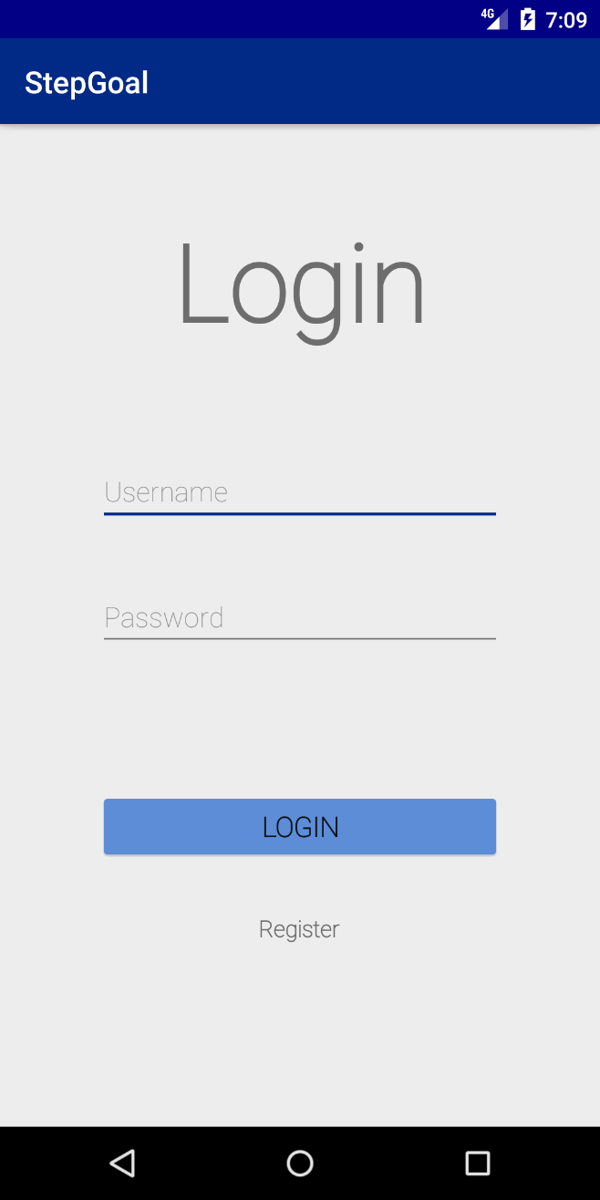

**Register**

If the user selects the “Register” button, they are brought to the following registration page. The user can enter a new username and password, and will be able to register their new account.

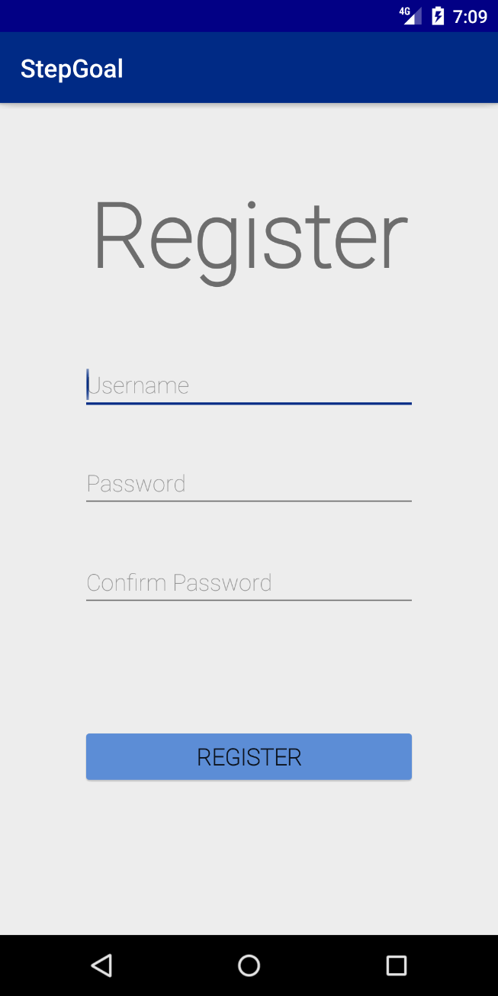

**Home**Once the user has logged in, they are brought to the home screen, which includes the following functionality:

* The daily step count of the user: From the accelerometer.
* Step count goal: User selected step count goal for each day. The progress bar shows current step count over goal step count (progress during the day).
* Calories burnt: The application will calculate calories burnt so far, during the current day.
* Time spent exercising: The duration of time that the user has exercised for during the current day.
* Distance travelled: The step counter will calculate distance travelled using step length (calculated from height).
* Imperial/ Metric conversion: The application can be set to either show values in imperial or metric units.
* Menu (displayed on the next page): Allows for easy navigation of functions.

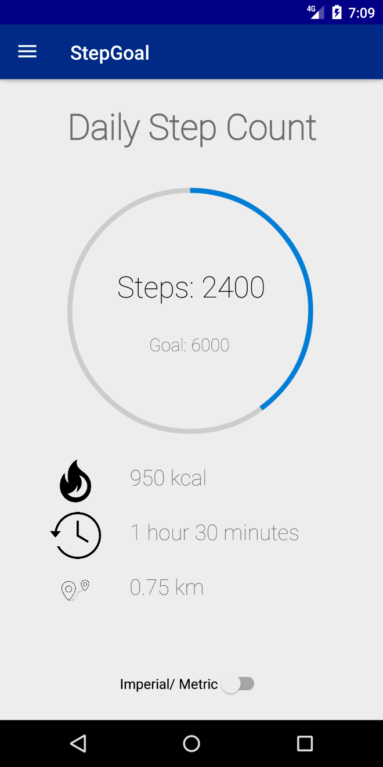

**Menu**

When the user selects the menu button (top left of home screen), a navigation drawer is shown. This provides access to the following functionality:

* Step Counter: Home screen.
* Goals: Allows users to specify a daily step count goal and weight targets.
* Fitness Log: Displays step count over the past week.
* Pictures: Allows the user to take pictures and view them from within the application.
* Calculate BMI: The user can calculate their BMI on this page.
* Weight Monitoring: Allows the user to enter their current weight, and shows trends over the past week.
* Personal Information: The user can set their personal information on this page.
* Log Out: Allows the user to log out of the application.
* Erase Step Count: Deletes the step count for the current day.

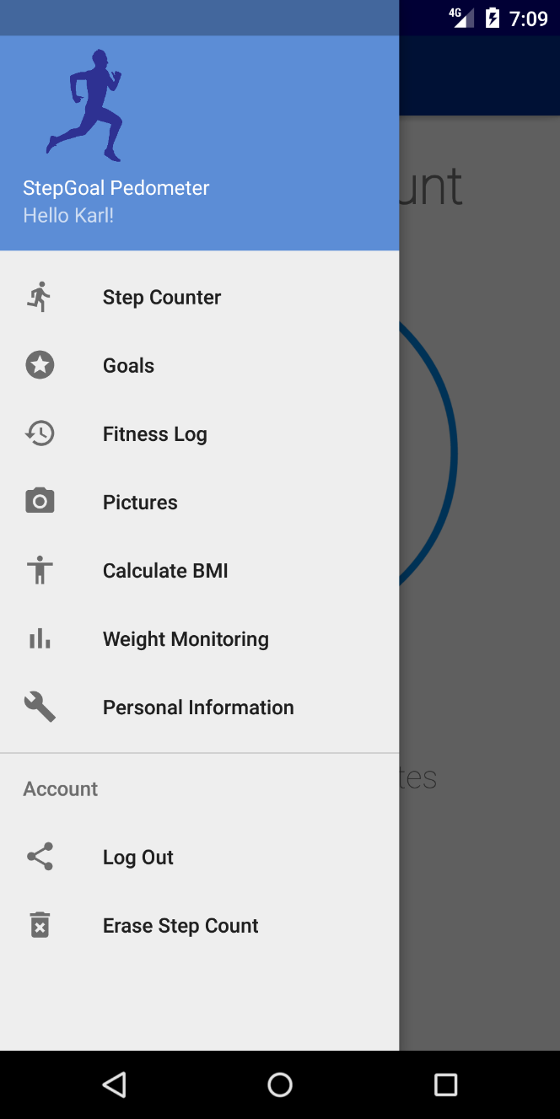

**Goals**

The user may set a daily step count goal, and weight target on this page. They may enter this information in either Imperial or Metric units using the toggle switch.

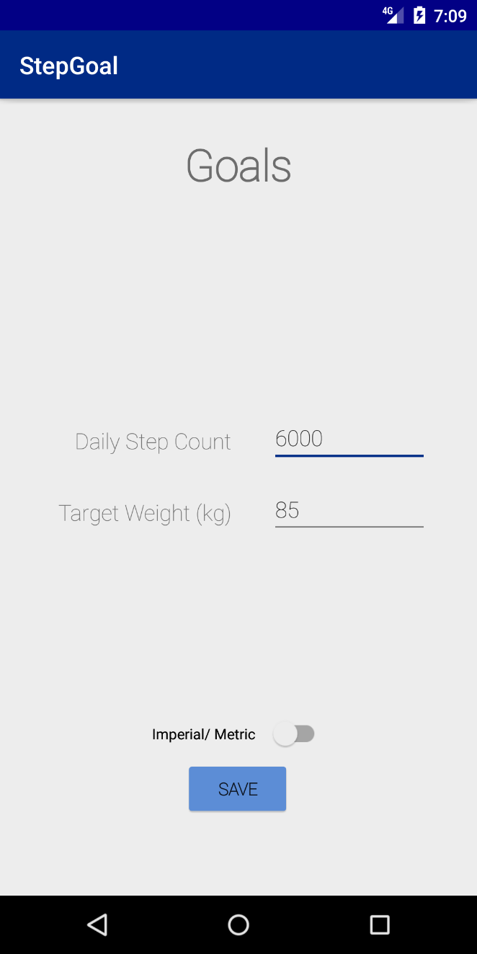

**Fitness Log**

The user may view their step count over the past week within the “Fitness Log” page. It also displays their daily step count goal.

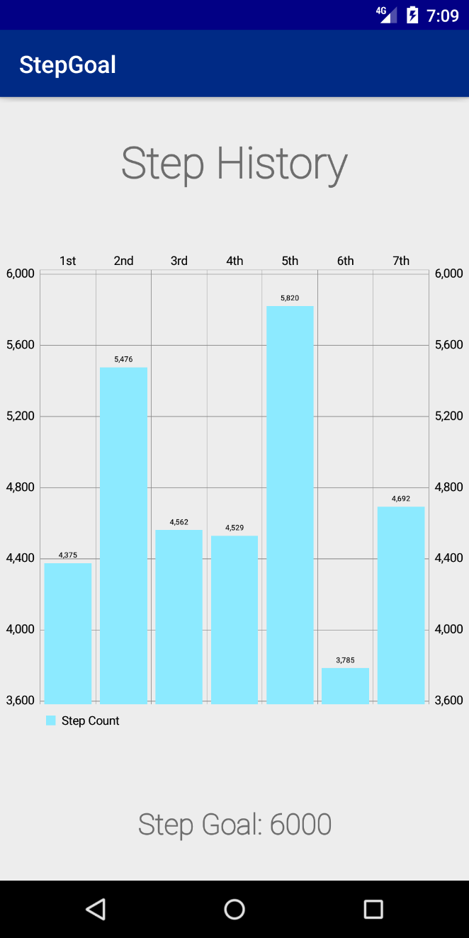

**Pictures**

This feature allows users to take pictures, and view them within the application. When the user selects “Capture Image”, it will bring them to a camera application, which displays the image above the button. The user may scroll through images that they have taken on this panel.

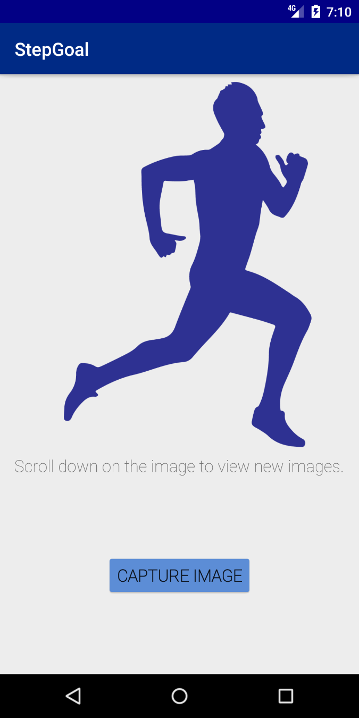

**Calculate BMI**

When the user selects this menu item, the user is brought to a page which allows them to enter their weight and height, and it will calculate their BMI once they press the “Calculate” button.

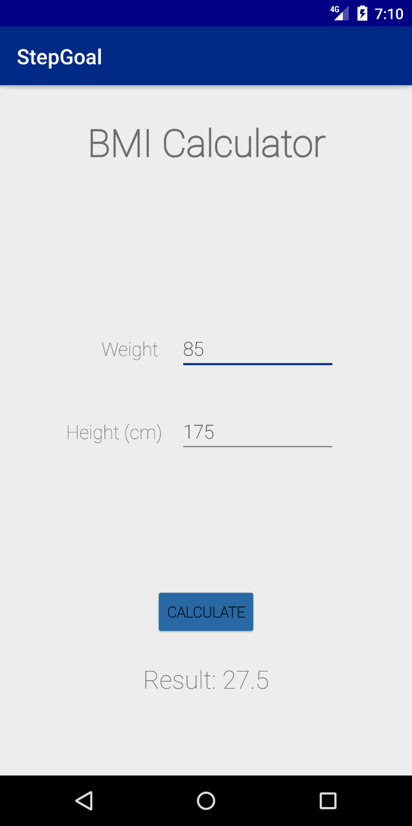

**Weight Monitoring**

The weight monitoring page will allow the user to view weight trends. They can enter a new weight in either pounds or kilograms, and this will be added to their health log.

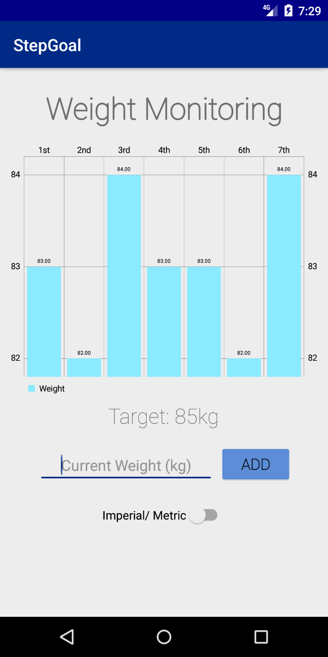

**Personal Information**

The user may edit their personal information on this page, including:

* First Name
* Last Name
* Weight
* Height
* Age

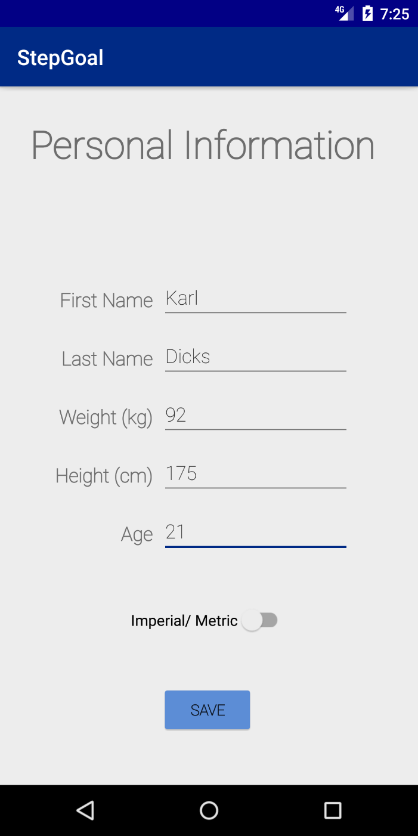

If the user selects the Imperial/ Metric toggle button, the units will be changed from metres and kilograms, to inches and pounds, as shown on the next page.

**Personal Information (Imperial Units)**

This setting can be changed on most pages of the application (where units can be converted).

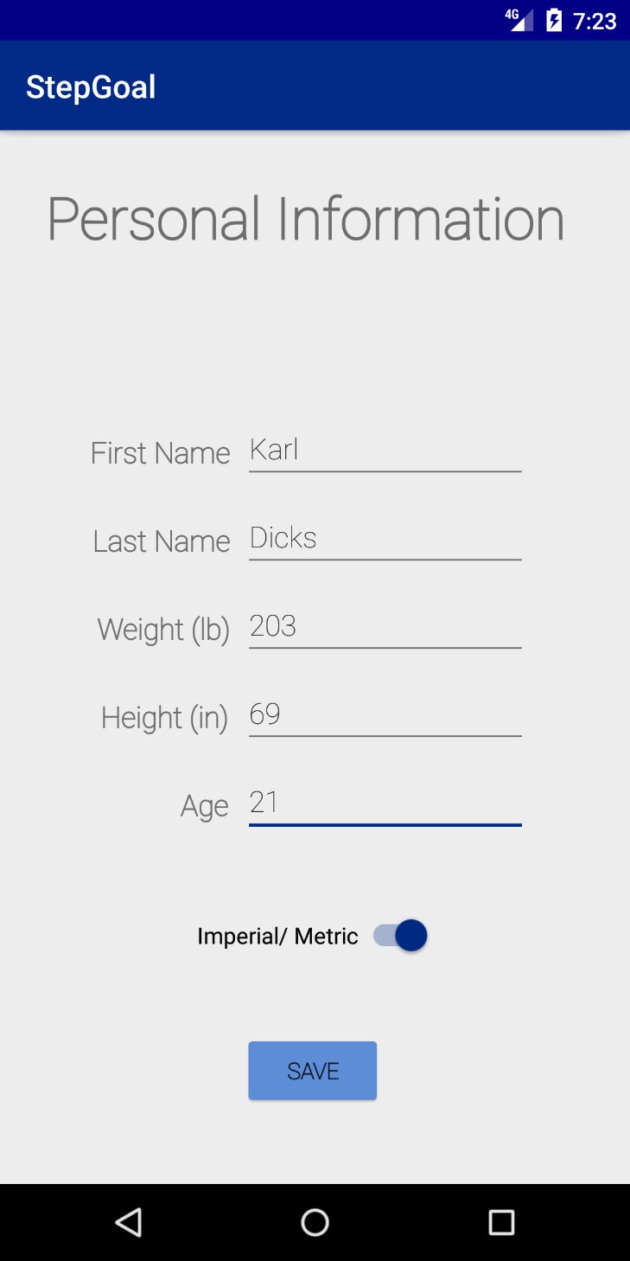

## Detailed Listing of Data and Types

|  |  |  |  |  |
| --- | --- | --- | --- | --- |
| **Data Name** | **Type (Java)** | **Type (SQL)** | **Nullable** | **Length** |
| **UserID** | String | Varchar | False | 255 |
| **Username** | String | Varchar | False | 255 |
| **Password** | String | Varchar | False | 255 |
| **First Name** | String | Varchar | False | 25 |
| **Last Name** | String | Varchar | False | 25 |
| **Age** | Int | Integer | False | 3 |
| **Height** | Int | Integer | False | 3 |
| **Weight** | Int | Integer | False | 3 |
| **Step Goal** | Int | Integer | True | 25 |
| **Target Weight** | Double | Decimal | True | (5, 2) |

Some data will be calculated within the application, including:

|  |  |  |  |  |
| --- | --- | --- | --- | --- |
| **Data Name** | **Type (Java)** | **Type (SQL)** | **Nullable** | **Length** |
| **BMI** | Double | Decimal | True | (5,2) |
| **Total Step Count** | Int | Integer | True | 255 |
| **Daily Step Count** | Int | Integer | True | 255 |
| **Completed Step Goal Percentage** | Double | Decimal | True | (250, 2) |
| **Completed Weight Goal Percentage** | Double | Decimal | True | (250, 2) |

Some considerations will be taken when implementing the system, including:

* All data will be stored in Metric units, and only displayed in Imperial units if the user requests this conversion.
* All information stored on the device will only be accessible by the logged in user. A username/ password authentication mechanism will provide this security.
* A UserID will be automatically generated for the signed up user. They will not be able to specify their own ID. This is generated by the autonumber/ identity database column.
* Daily step count is refreshed each day, in order to prepare the application for the next day. The count is saved to a database, and reset on the device.
* Step Goal and Target Weight are nullable, as users do not have to set these values. They can use the pedometer without goals.

How will the data be stored?

An SQL Lite database is available on all Android smartphones, which provides full relational database functionality. This database will be used to store all data in the system, including login information for the user.

|  |  |  |  |  |
| --- | --- | --- | --- | --- |
| Project Plan | | | | |
| **WBS Number** | **Task Description** | **Dependencies** | **Start Date** | **End Date** |
| **1** | **Research** |  | **13/08/2019** | **24/08/2019** |
| 1.1 | Identify available Android fitness applications from the Play Store, and determine if they are suitable for this scenario. |  | 13/08/2019 | 13/08/2019 |
| 1.2 | Summarize functionality of the application, and determine innovative features. |  | 14/08/2019 | 15/08/2019 |
| 1.3 | Evaluate strengths and weaknesses of the application. |  | 16/08/2019 | 17/08/2019 |
| 1.4 | Create a master list of all functionality, for further analysis. |  | 18/08/2019 | 19/08/2019 |
| 1.5 | Compare applications, including functionality, design, and ease of use. |  | 19/08/2019 | 19/08/2019 |
| 1.6 | Create a list of features that the developer would like to implement in our task two and three submissions. |  | 20/08/2019 | 20/08/2019 |
| 1.7 | Perform risk and feasibility analysis before commencing design of the application. |  | 20/08/2019 | 24/08/2019 |
| **2** | **Plan** |  | **25/08/2019** | **28/08/2019** |
| 2.1 | Continue feasibility analysis, to determine resource requirements, technological challenges, and risks. | Dependent on 1.7 | 25/08/2019 | 25/08/2019 |
| 2.2 | Determine major components that the new application will require. | Dependent on 1.6 | 26/08/2019 | 26/08/2019 |
| 2.3 | Schedule the work, and ensure tasks are completed sequentially or are able to be completed concurrently. | Dependent on 2.2 | 26/08/2019 | 26/08/2019 |
| 2.4 | Set up development environment, and prepare for the design phase. |  | 27/08/2019 | 27/08/2019 |
| 2.5 | Prepare estimated timeline of when milestones will be completed. This will ensure that there is enough time to develop the application. | Dependent on 2.3 | 28/08/2019 | 28/08/2019 |
| **3** | **Design** |  | **29/08/2019** | **05/09/2019** |
| 3.1 | Design the user interfaces of the application, using Android Studio. Determine how the user will navigate through the application, and how they will interact with functionality. | Dependent on 2.2 | 29/08/2019 | 31/08/2019 |
| 3.2 | Design the database schema and tables. The developer can use the data listing from the previous section. | Dependent on 2.2 | 01/09/2019 | 01/09/2019 |
| 3.3 | Design methods and classes that the application will require to support functionality. | Dependent on 2.2 | 02/09/2019 | 02/09/2019 |
| 3.4 | Design integrity controls, such as max input lengths, and security controls that prevent unauthorised access. A password policy can be developed. | Dependent on 2.2 | 03/09/2019 | 03/09/2019 |
| 3.5 | Design backup features which will allow users to back up their personal and fitness information on the phone. | Dependent on 2.2 | 04/09/2019 | 04/09/2019 |
| 3.6 | Develop test plan for the application. | Dependent on 2.2 | 05/09/2019 | 05/09/2019 |
| **4** | **Build** |  | **06/09/2019** | **03/10/2019** |
| 4.1 | Build all application components for the system, including the user interface, and features. This includes all text fields, buttons, and other such user interface elements. | Dependent on 3.1 | 06/09/2019 | 18/09/2019 |
| 4.2 | Develop the database for the application. | Dependent on 3.2 | 19/09/2019 | 19/09/2019 |
| 4.3 | Perform testing to ensure that the application does not have any bugs. The developer should also assess quality – which ensures maintainability, and a high level of accuracy is achieved. | Dependent on 3.6 | 20/09/2019 | 25/09/2019 |
| 4.4 | Perform final analysis, before the application is published and deployed on the Android Play Store. A google developer account will be required to complete this step. |  | 23/09/2019 | 25/09/2019 |
| 4.5 | Develop application documentation, for users and maintenance. This will assist users of the application if they require help. |  | 26/09/2019 | 03/10/2019 |
| **5** | **Evaluate** |  | **04/10/2019** | **09/10/2019** |
| 5.1 | Determine development inefficiencies, and find ways to overcome these delays. |  | 04/10/2019 | 06/10/2019 |
| 5.2 | Evaluate the final application, and compare it with competitors. Does it complete all functionality that is required? | Dependent on 4.4 | 07/10/2019 | 07/10/2019 |
| 5.3 | Deploy the solution. | Dependent on 4.3, 4.4 | 08/10/2019 | 08/10/2019 |
| 5.4 | Maintain the application, and provide support for users. | Dependent on 4.5 | 09/10/2019 | 09/10/2019 |

(The Independent Institute of Education (Pty) Ltd, 2019)

**Project Plan (continued)**

**Problem and solution domain:**As part of our OPSC7311 module, we have been tasked with developing a fitness tracking application for the Android mobile platform. This application aims to improve fitness of the user, by counting their daily steps, monitoring their weight, and allowing them to set fitness goals for these aspects. The application must support the built in pedometer functionality of the smartphone, by using its accelerometer motion sensor. This functionality has been included in the assignment question paper, and also stated in the list of functions previously. (The Independent Institute of Education (Pty) Ltd, 2019)

In order to best fulfil these requirements, an android application will be developed, which will contain the required functionality. An easy to use user interface will be developed, so that the user can easily navigate to these features.

**Milestones and deliverables:**

Major milestones and a timeline is provided below:

* Complete research of existing applications (11 days)
* Plan project including the following (3 days):
  + Develop detailed list of major components
  + Determine feasibility
  + Develop time estimation
  + Set up environment
* Design all system components (7 days):
  + Database
  + User interfaces
  + Functionality
  + Integrity controls
* Build all system components (27 days):
  + Database
  + User interfaces
  + Functionality
  + Integrity controls
  + Complete testing
  + Documentation
* Evaluate development process (5 days).

## Conclusion

This design documentation has provided an in depth analysis into how we will implement our fitness tracking applications on the Android platform. Firstly, it provided a list of functions which the application will have to implement, and how best this will be accomplished. It then provided implementation details for the functions by providing a user interface design, and navigation details between each application screen. The user interface was designed so that the developer would understand which features must be implemented. Easy navigation of these features is another key aspect that has been taken into consideration. The user interface was designed with this in mind.

Information datatypes and variable names were included, so that the developer could gain insight into what data the application will have to maintain. Further implementation details of the database were included. This has helped to structure development into distinct areas, such as user interface design, database design, feature design, and so on.

Finally, a project plan was developed in order to list all milestones and deliverables. This included a timeline, which was based on assignment due dates. The project plan included dependencies, where previous tasks must be completed before the developer can progress to the next task.

With the design documentation completed, the developer can continue to the build stage of application development. The user interface has already been developed on Android Studio, so moving this to a prototype build will be the next step in this process. This will be completed for our task two submission.

# Bibliography

Banks, L., n.d.. *S Health: Worth The Switch?.* [Online]   
Available at: https://fitlifepursuits.com/shealth-app-worth-it/  
[Accessed 03 09 2019].

Brian Chau, M., 2015. *Accupedo is an outstanding pedometer app with some evidence to support effectiveness.* [Online]   
Available at: https://www.imedicalapps.com/2015/11/accupedo-iphone-android-pedometer-app-review/  
[Accessed 01 09 2019].

Bumgardner, W., 2019. *Pedometer Apps for iOS and Android.* [Online]   
Available at: https://www.verywellfit.com/pedometer-apps-to-get-you-moving-3434996  
[Accessed 01 09 2019].

Choudhary, P., 2019. *Samsung Health app review.* [Online]   
Available at: http://bestappsguru.com/samsung-health-app-review/  
[Accessed 02 09 2019].

Corusen LLC, 2019. *Accupedo.* [Online]   
Available at: http://www.accupedo.com/  
[Accessed 01 09 2019].

Corusen LLC, 2019. *Accupedo Pedometer - Step Counter.* [Online]   
Available at: https://play.google.com/store/apps/details?id=com.corusen.accupedo.te  
[Accessed 01 09 2019].

FreeAppsForMe, 2019. *15 Best step counter apps for Android & iOS.* [Online]   
Available at: https://freeappsforme.com/step-counter-apps/#leap-step-counter-8211-pedometer-free-amp-calorie-counter  
[Accessed 03 09 2019].

FreewareFiles, 2019. *5 Useful Pedometer Apps For Android.* [Online]   
Available at: https://www.freewarefiles.com/news/android/5-useful-pedometer-apps-for-android/  
[Accessed 03 09 2019].

Leap Fitness Group, 2019. *Step Counter - Pedometer Free & Calorie Counter.* [Online]   
Available at: https://play.google.com/store/apps/details?id=pedometer.steptracker.calorieburner.stepcounter&hl=en_ZA  
[Accessed 04 09 2019].

Samsung, 2019. *Samsung Health.* [Online]   
Available at: https://www.samsung.com/za/apps/samsung-health/  
[Accessed 02 09 2019].

Samsung, 2019. *Samsung Health.* [Online]   
Available at: https://play.google.com/store/apps/details?id=com.sec.android.app.shealth&hl=en_ZA  
[Accessed 03 09 2019].

Softonic, 2019. *Step Counter Pedometer Free Calorie Counter.* [Online]   
Available at: https://step-counter.en.softonic.com/android  
[Accessed 03 09 2019].

Soman, S. V., 2019. *Google Fit vs Samsung Health: A Complete Guide By DigitMize.* [Online]   
Available at: https://digitmize.com/google-fit-vs-samsung-health/  
[Accessed 03 09 2019].

The Independent Institute of Education (Pty) Ltd, 2019. *OPEN SOURCE CODING (INTRODUCTION),* Sandton: The Independent Institute of Education (Pty) Ltd.